Year 4 -  Miss Derbyshire  Mrs Norbury | Spring Term 2023
 | Diverse Earth
English  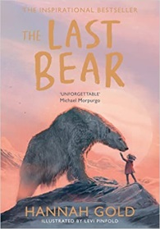     | Reading Comprehension  - Continue to skim and scan texts of increasing complexity  - Draw inferences such as inferring characters’ feelings, thoughts and motives from their actions, and justify inferences with evidence  - Summarise paragraphs  - Predict what might happen from details stated and implied  - Use dictionaries to check the meaning of words that they have read  Writing  - Explore the structure and language features of a range of texts (adventure story, diary, archaic poetry, non-chronological report, persuasive letter, interview text)  - Use an increasing range of conjunctions to write complex sentences  - Use prepositional phrases to add detail to sentences  - Accurately use inverted commas and other punctuation to indicate direct speech  - Use the apostrophe to show possession (singular and plural)  - Organise paragraphs around a theme  - Edit and improve their own writing to improve accuracy and quality of vocabulary  - Read their own writing aloud to a group or the whole class, using appropriate intonation and controlling the tone and volume so that the meaning is clear  Handwriting  - Increase the legibility, consistency and quality of their handwriting, (for example, by ensuring that the down strokes of letters are parallel and equidistant, and that lines of writing are spaced sufficiently so that the ascenders and descenders of letters do not touch)  Spelling  - Year 3/4 common exception words  - Use the first 2 or 3 letters of a word to check its spelling in a dictionary  - Spell further homophones | Maths    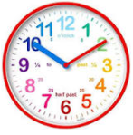  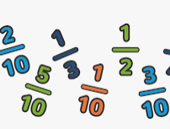    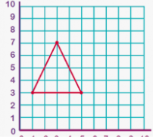 | Multiplication and Division  - Multiply and divide by all multiplication facts up to 12x12  - Multiply 3 single digit numbers together and know that they can be multiplied in any order  - Factor pairs – multiply two numbers to find a product e.g. 3 x 5=15  - Multiply and divide by 10 and 100  - Learn formal written methods to multiply 2 and 3-digit numbers by a 1-digit number  - Learn written methods to divide 2 and 3-digit numbers by a 1-digit number  - Apply written methods to solving real-life problems  Measures – Time  - Telling the time to the nearest 5 minutes and the nearest minute on an analogue clock using am and pm  - Tell the time on a digital clock in 12 and 24-hour format  - Convert between hours, minutes and seconds as well as years, months, weeks and days  Fractions  - Understand the whole, count beyond 1  - Partition, compare and order mixed numbers  - Understand and convert improper fractions  - Convert between improper fractions and mixed numbers and vice versa  - Find equivalent fractions  - Add two or more fractions, including mixed numbers  - Subtract two fractions from whole amounts or mixed numbers  Number and Place Value  - Find 1, 10, 100, 1000 more or less than a number  - Compare numbers to 10,000  - Order numbers to 10,000  - Round to the nearest 10, 100, 1,000  - Count in 25s  - Negative numbers  Statistics  - Know how to use bar charts, pictograms and tables to interpret data  - Know the most appropriate scale to use when drawing bar charts  - Solve comparison, sum and difference problems using discrete data  - Introduce line graphs and know that these represent continuous data e.g. time, temperature and height  Position and Direction  - Introduce coordinates and describe positions in the first quadrant  - Learn which is the x-axis and y-axis  - Read and write coordinates accurately knowing which one to write first (x, y)  - Plot coordinates correctly on a grid in the first quadrant  - Know that translation means to move a shape to a new position on a coordinate grid  - Follow specific directions such as left/right and up/down to translate a shape  - Be able to describe how a shape has been moved on a grid e.g. 3 squares left and 4 squares down.  - Solve problems involving position and direction
SCIENCE  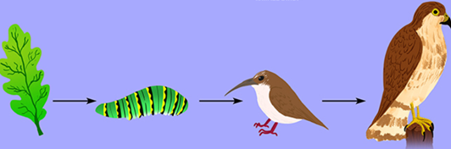  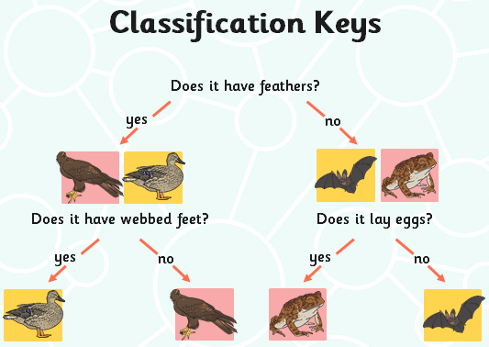 | Animals including humans  - Construct and interpret a variety of food chains, identifying producers, predators and prey  - Construct a food web relating to the local environment  Living Things and their habitats  - Recognise that living things can be grouped in a variety of ways  - Explore and use classification keys to help group, identify and name a variety of living things in their local and wider environment  - Recognise that environments can change and that this can sometimes pose dangers to living things | HISTORY | Geography is the focus for the Spring Term
GEOGRAPHY   | Locational Knowledge  Locate the world’s countries, using maps to focus on Northern Europe countries and North America concentrating on their environmental regions, key physical and human characteristics, countries, and major cities  Physical geography-  Describe and understand key aspects of climate zones and biomes - focus on Arctic (North America), UK and Italy  - Locate on a globe/map: the Equator, Northern and Southern Hemispheres, the Tropics of Cancer and Capricorn, the Arctic and Antarctic Circles  - Know the difference between climate zone and biome  - Understand and learn about different climate zones (polar, arid, temperate) and biomes (e.g. tundra)  - Know why certain animals live in certain areas and how they are suited to their environment  - Learn about food chains in the polar climates  - Know how climate zones differ between the UK, Alaska (North America) and Italy  - Identify the different biomes in these areas | COMPUTING   | Photo Editing  Developing an understanding of how digital images can be changed and edited  - Changing digital images  - Changing the composition of images  - Changing images for different uses  - Retouching images  - Fake images  - Making and evaluating a publication  Repetition in shapes  Creating programs by planning, modifying, and testing commands to create shapes and patterns  - Programming a screen turtle  - Programming letters  - Patterns and repeats  - Using loops to create shapes  - Breaking things down  - Creating a program
PSHE   | Dreams and Goals  - Hopes and dreams  - Overcoming disappointment  - Creating new, realistic dreams  - Achieving goals  - Working in a group  - Celebrating contributions  - Resilience  - Positive attitudes  Healthy Me  - Healthier friendships  - Group dynamics  - Smoking  - Alcohol  - Assertiveness  - Peer pressure  - Celebrating inner strength | RE   | Buddhism  - Listen to the lyrics of the song ‘A Wonderful World’ by Louis Armstrong  - Discuss what makes our world a wonderful place to live in  - Think about people who may not be in a good situation in the world right now. What might be causing suffering or unpleasantness? How could other people help to change this?  - Learn about the Life of the Buddha, including the truths that he taught to everyone  - Focus on how everything changes and people don’t want it to and suffering that is caused by selfishness  - Understand about the Noble Eightfold Path which Buddhists follow  Christianity - Easter  - Establish the meaning of the word ‘forgiveness’  - Show understanding of ‘forgiveness’ through creating and performing drama scenarios in small groups  - Learn about who Jesus was and why children think he had enemies  - Read Biblical texts which show the Christian understanding of forgiveness  - Did Jesus always forgive people?  - Discuss what Christians believe about Jesus’s death and the link with forgiveness
ART  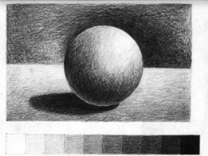 | Tonal Drawings  Begin to show the third dimension of objects using tone, shade and tints  - What is tone? Explore tonal shapes using a range of sketching pencils  - Begin to develop their own style using tonal contrast and mixed media (charcoal and white chalk)  - Compare ideas, methods and approaches in their own and others’ work and say what they think and feel about them  - Explore and imitate the use of tone within the work of a variety of artists  - Create a drawing showing depth and tone inspired by an artist’s work  - Adapt their work according to their views and describe how they might develop it further | Design and Technology | Levers and Linkages  Design an Easter/Spring card for a relative  Designer: Robert Sabuda  - Investigate and evaluate books where lever and linkage mechanisms have been used  - Learn how lever and linkage mechanisms work and, in small groups, produce a range of these types of mechanisms  - Design an Easter card with levers and linkages which meets the design criteria (include measurements)  - Create a protype of their Easter card design and evaluate at this stage  - Make their final product based on their design and prototype with amendments made according to the evaluation of the prototype  - Evaluate their final product identifying what went well and how they could improve their product next time
MUSIC   | Stop!  Our learning is focused around one song ‘Stop!’ which is a grime/rap song about bullying. Children will appraise and identify the main sections of the song. Through games, they will move to the pulse and clap back rhythms. Children will write and perform their own lyrics linked to the theme of bullying.  Lean on Me  Our Learning is focused on the gospel style song ‘Lean on Me’. Children will sing in unison and play instrumental parts by ear and/or from notation using the easy or medium parts.  Children will compose a melody using simple rhythms. | MFL   | Fruit  - Learn the names and spelling of common fruits  - Be able to say which fruits are liked or disliked  Presenting Myself  - Count to 20 in Spanish  - Say their name and age in Spanish  - Say hello and goodbye and then ask how somebody is feeling and answer in return how they are feeling  - Learn and use the Spanish for “I am” (Soy), “I have” (Tengo) and “I live” (Vivo)  - Tell you if they are Spanish or English, introducing concept of gender and agreement
PE   | Outdoor learning – Forest School  - Learn the eight-point compass and to be able to write and follow directions using these  - What causes global warming? How is this linked to fires?  - Light a fire and toast marshmallows, create a bird feeder  - Learn and discuss about habitat loss and create a suitable habitat for a UK animal  Outdoor and adventurous  - Work in teams to develop their problem-solving skills  - Navigate around a space whilst developing map-reading skills  - Create symbols which are effective for map-reading  - Develop skills such as balance and coordination  Netball  - Learn and use the correct passes used in netball  - Know and use the footwork techniques to be used in a game  - Learn the different positions in High 5 Netball  - Be able to play in any position on the netball court  - Apply skills learned in a competitive 5 a side game  Tennis  - Develop an understand of the ‘ready’ position  - Develop co-ordination and control of a variety of shots (forehand, backhand and volley)  - Create their own games applying skills and knowledge taught | Additional Information | PE days  - Term 3: Monday and Thursday (Forest School)  - Term 4: Monday and Friday  Homework Days  - English is set on a Wednesday and is due in on the following Monday  - Maths is set on a Friday and is due in on the following Thursday  - Spelling test every two weeks on a Friday

