Year 4 -  Miss Derbyshire  (M,T&W)  Miss Fytche (Th& F) | Spring Term 2025
 | Diverse Earth
English  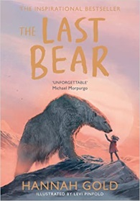     | Reading Comprehension  - Continue to skim and scan texts of increasing complexity  - Draw inferences such as inferring characters’ feelings, thoughts and motives from their actions, and justify inferences with evidence  - Summarise paragraphs  - Predict what might happen from details stated and implied  - Use dictionaries to check the meaning of words that they have read  Writing  - Explore the structure and language features of a range of texts (adventure story, missing chapter non-chronological report, persuasive letter)  - Use an increasing range of conjunctions to write complex sentences  - Use prepositional phrases to add detail to sentences  - Accurately use inverted commas and other punctuation to indicate direct speech  - Use the apostrophe to show possession (singular and plural)  - Organise paragraphs around a theme  - Edit and improve their own writing to improve accuracy and quality of vocabulary  - Read their own writing aloud to a group or the whole class, using appropriate intonation and controlling the tone and volume so that the meaning is clear  Spelling  - -ture  - Adding ly  - Ous  - Ch (‘sh)  - Qu/que  - Y for ‘i’  - Prefix ‘sub’  - Prefix ‘mis’  - -sion  - Possessive apostrophes with plural words  - Statutory words –ly  - Y making the e sound | Maths    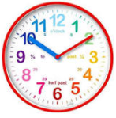  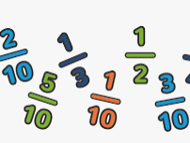  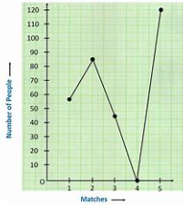  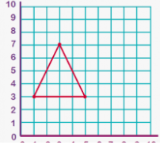 | Multiplication and Division  - Multiply and divide by all multiplication facts up to 12x12  - Factor pairs – multiply two numbers to find a product e.g. 3 x 5=15  - Multiply and divide by 10 and 100  - Learn formal written methods to multiply 2 and 3-digit numbers by a 1-digit number  - Learn written methods to divide 2 and 3-digit numbers by a 1-digit number  - Apply written methods to solving real-life problems  Measures – Time  - Telling the time to the nearest 5 minutes and the nearest minute on an analogue clock using am and pm  - Tell the time on a digital clock in 12 and 24-hour format  - Convert between hours, minutes and seconds as well as years, months, weeks and days  Fractions  - Understand the whole, count beyond 1  - Partition, compare and order mixed numbers  - Understand and convert improper fractions  - Convert between improper fractions and mixed numbers and vice versa  - Find equivalent fractions  - Add two or more fractions, including mixed numbers  - Subtract two fractions from whole amounts or mixed numbers  Statistics  - Know how to use bar charts, pictograms and tables to interpret data  - Know the most appropriate scale to use when drawing bar charts  - Solve comparison, sum and difference problems using discrete data  - Introduce line graphs and know that these represent continuous data e.g. time, temperature and height  Position and Direction  - Introduce coordinates and describe positions in the first quadrant  - Learn which is the x-axis and y-axis  - Read and write coordinates accurately knowing which one to write first (x, y)  - Plot coordinates correctly on a grid in the first quadrant  - Know that translation means to move a shape to a new position on a coordinate grid  - Follow specific directions such as left/right and up/down to translate a shape  - Be able to describe how a shape has been moved on a grid e.g. 3 squares left and 4 squares down.  - Solve problems involving position and direction
SCIENCE  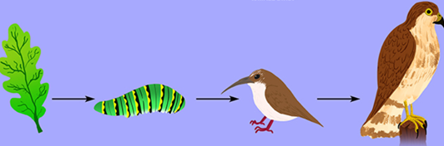  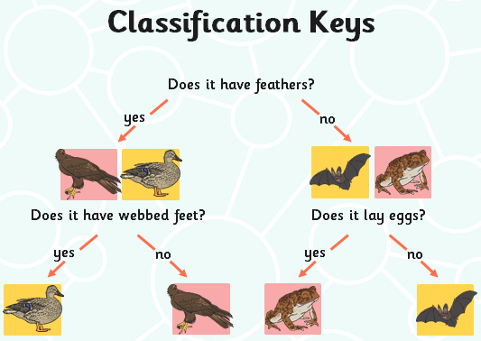 | Animals including Humans  - Construct and interpret a variety of food chains, identifying producers, predators and prey  - Construct a food web relating to the local environment  Living Things and their Habitats  - Recognise that living things can be grouped in a variety of ways  - Explore and use classification keys to help group, identify and name a variety of living things in their local and wider environment  - Recognise that environments can change and that this can sometimes pose dangers to living things | HISTORY | Geography is the focus for the Spring Term
GEOGRAPHY   | Locational Knowledge  Locate the world’s countries, using maps to focus on Northern Europe countries and North America concentrating on their environmental regions, key physical and human characteristics, countries, and major cities  Physical geography-  Describe and understand key aspects of climate zones and biomes - focus on Arctic (North America), UK and Italy  - Locate on a globe/map: the Equator, Northern and Southern Hemispheres, the Tropics of Cancer and Capricorn, the Arctic and Antarctic Circles  - Know the difference between climate zone and biome  - Understand and learn about different climate zones (polar, arid, temperate) and biomes (e.g. tundra)  - Know why certain animals live in certain areas and how they are suited to their environment  - Learn about food chains in the polar climates  - Know how climate zones differ between the UK, Alaska (North America) and Italy  - Identify the different biomes in these areas | COMPUTING  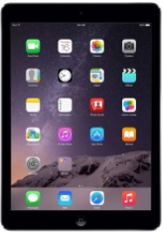 | Photo Editing  Developing an understanding of how digital images can be changed and edited  - Changing digital images  - Changing the composition of images  - Changing images for different uses  - Retouching images  - Fake images  - Making and evaluating a publication  Repetition in shapes  Creating programs by planning, modifying, and testing commands to create shapes and patterns  - Programming a screen turtle  - Programming letters  - Patterns and repeats  - Using loops to create shapes  - Breaking things down  - Creating a program
PSHE   | Dreams and Goals  - Hopes and dreams  - Overcoming disappointment  - Creating new, realistic dreams  - Achieving goals  - Working in a group  - Celebrating contributions  - Resilience  - Positive attitudes  Healthy Me  - Healthier friendships  - Group dynamics  - Smoking  - Alcohol  - Assertiveness  - Peer pressure  - Celebrating inner strength | RE   | Buddhism  Can the Buddha’s teachings make the world a better place?  - To consider how the world is a wonderful place for some people and a less wonderful place for others  - To explain how Anicca (change) might bring about Dukkha (suffering) for some people  - To re-tell a Buddhist story and explain its meaning  - To re-tell a Buddhist story and explain how it shows compassion  - To explain how the teachings of Buddha might impact on the life of a Buddhist today  - To talk about changes in my life and how these might bring positive outcomes for me  Christianity – Easter  - To explain what forgiveness is and why it might be difficult in some situations  - To describe what a Christian might learn about forgiveness from a Bible story  - I can retell a Bible story where Jesus forgave somebody  - To discuss how some Christians might feel about forgiveness  - To describe what a Christian might learn about forgiveness from a Bible text  - To explain what forgiveness might mean to me
ART  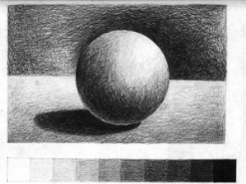 | Tonal Drawings  Begin to show the third dimension of objects using tone, shade and tints  - What is tone? Explore tonal shapes using a range of sketching pencils  - Begin to develop their own style using tonal contrast and mixed media (charcoal and white chalk)  - Compare ideas, methods and approaches in their own and others’ work and say what they think and feel about them  - Explore and imitate the use of tone within the work of a variety of artists  - Create a drawing showing depth and tone inspired by an artist’s work  - Adapt their work according to their views and describe how they might develop it further | Design and Technology | Levers and Linkages  Design an Easter/Spring card for a relative  Designer: Robert Sabuda  - Investigate and evaluate books where lever and linkage mechanisms have been used  - Learn how lever and linkage mechanisms work and, in small groups, produce a range of these types of mechanisms  - Design an Easter card with levers and linkages which meets the design criteria (include measurements)  - Create a protype of their Easter card design and evaluate at this stage  - Make their final product based on their design and prototype with amendments made according to the evaluation of the prototype  - Evaluate their final product identifying what went well and how they could improve their product next time
MUSIC   | Rock and Roll  - To recognise and discuss the stylistic features of different genres, styles and traditions of music using musical vocabulary.  - Using musical vocabulary to discuss the purpose of a piece of music.  - Identifying common features between different genres, styles and traditions of music.  - Perform the hand jive actions in sequence and in time to the music on their own and individually.  - Sing in tune and in time to the music.  - Independently play their part with some awareness of other performers. | MFL   | Vegetables  · Name and recognise up to 10 vegetables in Spanish.  · Attempt to spell some of these nouns (including the correct article)  · Learn simple vocabulary to facilitate a role play about buying vegetables from a market stall.  Presenting Myself  - Count to 20 in Spanish  - Say their name and age in Spanish  - Say hello and goodbye and then ask how somebody is feeling and answer in return how they are feeling  - Learn and use the Spanish for “I am” (Soy), “I have” (Tengo) and “I live” (Vivo)  - Tell you if they are Spanish or English, introducing concept of gender and agreement
PE   | Outdoor learning – Forest School  - Creating natural art and stick frames.  - Learn about and find different insect habitats. Make bird feeders.  - Fire safety reminders and using natural materials to design and create a trail.  - Looking at natural versus man-made objects in the environment and the effects they can have.  - Identifying compass points and using them to create instructions to follow.  - Learning about what humans need to survive.  Orienteering  - Develop ability to orientate a map and locate points  - Apply understanding of what makes an effective team and understand how important teamwork is when orienteering.  - Develop life skills such as trust and communication as they collaborate with their team to successfully complete the orienteering challenges.  Dance (Weather)  - Perform with expression and emotion as they tell a story. Understand what makes an ‘excellent dance’.  - Apply creativity as they try a range of movement options.  - Strive to ensure their sequences are performed precisely and accurately showing self-motivation to want to improve.  Tennis  - Hit the ball into space on their opponent's side of the court, creating space for the next shot that will win them the point.  - Apply an accurate understanding of where, when and why we hit the ball into spaces on their opponent's side of the court.  - Develop and apply life skills such as resilience and self-motivation as they strive to improve their own performance and understanding. | Additional Information | PE days  - Term 3: Monday and Thursday (Forest School)  - Term 4: To be confirmed.  Homework  - New homework trial due to evidence based research focussing on core and non-core subjects. More details to follow.

