Year 5- Mr Moutrey | Spring Term 2025
 | The Maya
English  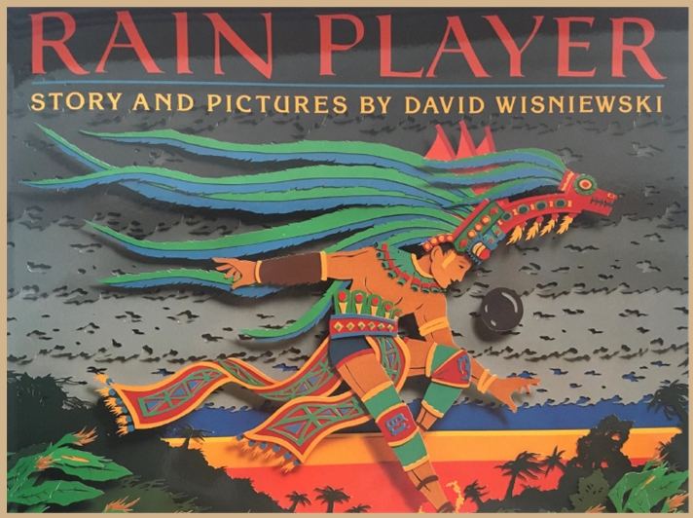  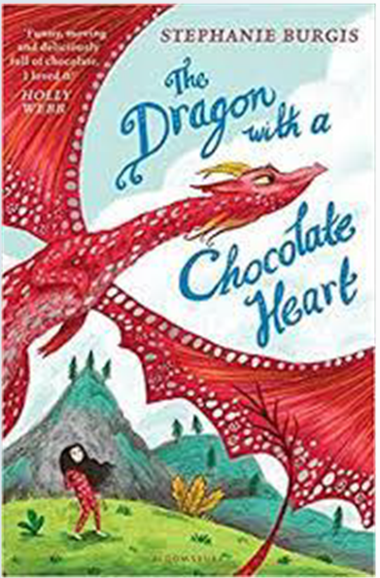 | Class novels: ‘Rain Player’ – David Wisniewski & ‘The Dragon with a Chocolate Heart’ – Stephanie Burgis  Daily Guided reading lessons based on a variety of fiction/ non-fiction texts.  - Recount (Space trip)  - Character Description  - Non-chronological report (History based)  - Dialogue/speech  - Role play  - Explanation Text (linked to DT work)  - Active Spelling lessons  - Punctuation and grammar work in Active English lessons | Maths  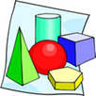 | Multiplication and Division  - Formal multiplication method  - Area model  - Short division  Fractions  - Multiplying fractions  - Fraction of a quantity  PiXL Assessments  Measure  - Length, Perimeter and Area  - Volume  - Time- Interpreting timetables  Statistics  - Tables and bar charts  - Line graphs and comparative graphs
SCIENCE   | Properties and Changes of Materials  - Compare and group together everyday materials on the basis of their properties, including their hardness, solubility, transparency, and response to magnets  - Know that some materials will dissolve in liquid to form a solution, and describe how to recover a substance from a solution  - Use knowledge of solids, liquids and gases to decide how mixtures might be separated, including through filtering, sieving and evaporating  - Give reasons, based on evidence from comparative and fair tests, for the particular uses of everyday materials, including metals, wood and plastic  - Demonstrate that dissolving, mixing and changes of state are reversible changes  - Explain that some changes result in the formation of new materials, and that this kind of change is not usually reversible, including changes associated with burning and the action of acid on bicarbonate of soda. | HISTORY  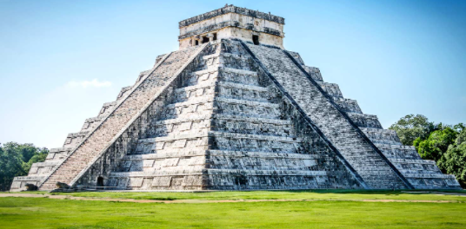 | A non-European society that provides contrasts with British history- Maya civilisation c. AD 900  - To know that the Maya were accomplished engineers, mathematicians and scientists  - To know and understand why the Maya had strong religious beliefs  - To know that the Maya civilization was dependent on farming, hunting and trading  - Investigating why the civilisation collapsed  - To know the legacies of the Maya civilisation e.g. engineering, number, trade etc
GEOGRAPHY   | Locational knowledge  - Locate the world’s countries, using maps to focus on South America, concentrating on their environmental regions, key physical and human characteristics, countries, and major cities | COMPUTING   | Flat-file databases  Use tools within a database to order and answer questions about data.  Selecting in physical computing  Exploring conditions and selection using a programmable microcontroller
PSHE     | Dreams and Goals  - Future dreams  - The importance of money  - Jobs and careers  - Dream job and how to get there  - Supporting others (charity)  - Motivation  Healthy Me  - Smoking  - Alcohol  - Alcohol and anti-social behaviour  - Emergency First Aid  - Relationship with Food  - Healthy Choices  - Motivation and behaviour | RE     | Theme: Beliefs and moral values  Key Question: Are Sikh stories important today?  Religion: Sikhism  Theme: Easter  Concept: Incarnation  Key Question: How significant is it for Christians to believe God intended Jesus to die?  Religion: Christianity
ART   | Textiles- Basket Weaving  Children will look into the craft and design of the Maya culture, such as the pine needle baskets and worry dolls.  They will experiment with colour pallets before designing and producing their own product. | Design and Technology  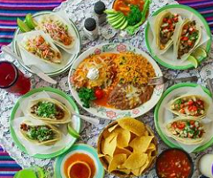 | Celebrating Culture and Seasonality  Children will research Mexican food before designing their own Mexican based meal.  Roots to Food will visit and assist the children with producing a Mexican based meal.
MUSIC  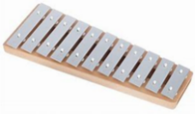   | Term 3: South and West Africa  Children will recognise and confidently discuss the stylistic features of different genres, styles and traditions of music using musical vocabulary.  Term 4: Composition Notation  Represent the features of a piece of music using graphic notation and colours, justifying their choices with references to musical vocabulary. | MFL   | My Home and Clothes  Repeat, recognise and try to spell up to ten nouns (including the correct article for each) for the rooms of the house in Spanish.
PE   | Term 3: Gymnastics  Handball  Term 4: Dance  Outdoor and adventurous |  | PE days- Mondays and Fridays  Bikeability – w/c 27th January  - Homework will be given out on Fridays and due on Wednesdays.  - Children will be expected to spend time reading and practising their times tables.

