Year 1  Miss Baldwin | Spring Term 2025  WHAT MAKES BRITAIN GREAT?
Spring 1
Spring 2
ENGLISH  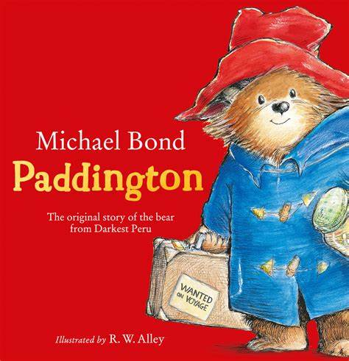 | - Reading: whole class, group and individual  - Phonics: Read Write Inc.  - Writing: fiction and non-fiction(letters, lists, fact file, story writing, invitations, news)  - ‘The Queen’s Hat’ and ‘The Queen’s Handbag’ by Steve Anthony  - Writing letters to King Charles III  - Paddington Bear stories  - Traditional Tales  - The Tiger Who Came To Tea  - Poems and rhymes  - Letter formation/handwriting | MATHS   | Number: Place Value (within 20)  Number: Addition and subtraction (within 20)  Number: Place Value (within 50)  Measurement: Length and height  Measurement: Weight and volume  Time (ongoing learning throughout the year)
SCIENCE  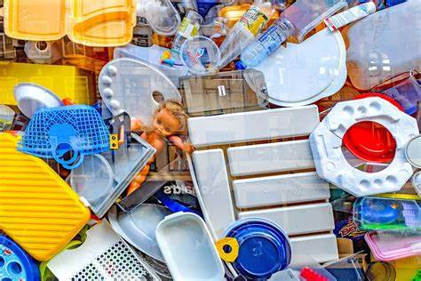  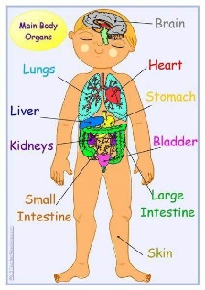 | Everyday Materials  - Describe the simple properties of a variety of everyday materials  - Compare and group together a variety of everyday materials on the basis of their simple physical properties  Seasonal Changes (ongoing - throughout the year)  - observe changes across the four seasons  - observe and describe weather associated with the seasons and how day length varies.  Animals including humans  - Basic parts of the human body.  - Which part of the body is associated with each sense. | HISTORY  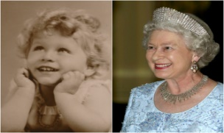   | Why will Queen Elizabeth be remembered?  Exploring the life of Queen Elizabeth II to develop curiosity about changes within living memory and an understanding of the ways we can find out about these changes.  - What is a Monarch?  - The Queen’s family  - The Queen’s Homes  - The Coronation  - The Queen’s Duties  - King Charles III and the new Monarch.
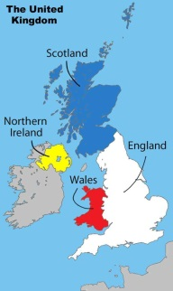  GEOGRAPHY  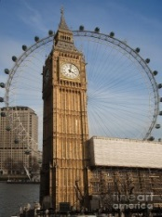 | Human and Physical geography  - identify seasonal and daily weather patterns in the United Kingdom  - use basic geographical vocabulary to refer to: key human features, including: city, town, village, factory, farm, house, office and shop.  Geographical skills and fieldwork  - use world maps, atlases and globes to identify the United Kingdom and its countries, as well as the countries, continents and oceans  - use simple compass directions (North, South, East and West) and locational and directional language [for example, near and far; left and right], to describe the location of features and routes on a map use aerial photographs and plan perspectives to recognise landmarks and basic human and physical features in London and across the UK.  - Devise a simple map; and use and construct basic symbols in a key. | COMPUTING  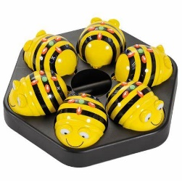 | Moving a Robot  - Writing short algorithms and programs for floor robots, and predicting program outcomes  Grouping Data  - Exploring object labels, then using them to sort and group objects by properties
PSHE   | Dreams and Goals  - Setting goals  - Identifying successes and achievements  - Learning styles  - Working well and celebrating achievement with a partner  - Tackling new challenges  - Identifying and overcoming obstacles  - Feelings of success  Healthy Me  - Keeping myself healthy  - Heathier lifestyle choices  - Keeping clean  - Being safe  - Medicine safety/safety within household items  - Road safety  - Linking health and happiness | 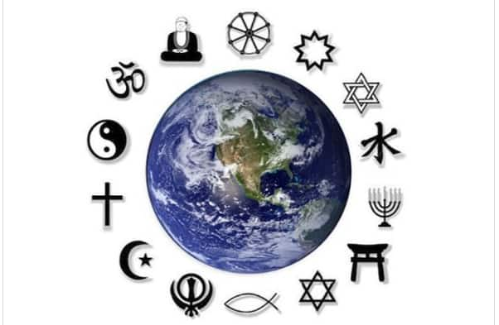  RE | Judaism- Who is God to Jews?  Theme: The special relationship that Jews have with God  Christianity- Why was Jesus welcomed like a king or a celebrity by the crowd on Palm Sunday?  Theme: Easter- Palm Sunday
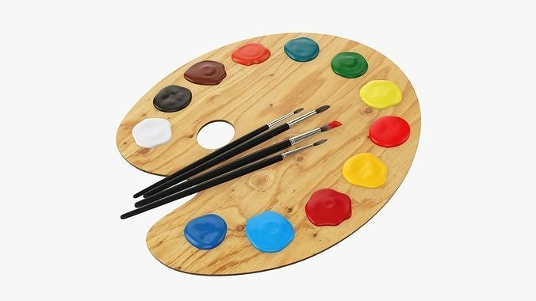  ART | Collage  Focus artists/artworks:  - Megan Coyle: City Landscapes London  - Henri Matisse: The Snail  - Explore the differences and similarities within the work of artists in different times and cultures.  - Identify shapes in buildings, thinking about how they can be represented in a collage.  - Evaluate their work and identify what they might change in their current work. | Design and Technology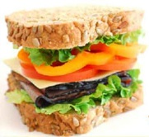 | Cookery  - Design and make a savoury sandwich  - Safely using tools, designing products, exploring techniques and talking about what and how something has been made.  - Sorting foods into the 5 groups, preparing simple dishes.  - Use principles of a healthy and varied diet to prepare dishes, including how fruit and vegetables are part of the Eatwell plate.
  MUSIC | Musical symbols - Theme under the sea.  - To be able to move at a speed that reflects the tempo of the music.  - To be able to sing and play high and low notes.  - To demonstrate an awareness of pitch, rhythm and dynamics.  Sound patterns- theme fairytales  - To be able to join in time with repeated phrase using a character voice.  - To be able to change the dynamics of their voice to represent a character.  - To be able to play given sound patterns in time with the pulse. |   MFL | Mini beasts  El erizo- hedgehog  La abeja- bee  La oruga- caterpillar  El gusano- worm  La mariposa- butterfly  El caracol- snail  La hormiga- fly  La rana- frog  La mariquita- ladybird  La arana- spider
PE  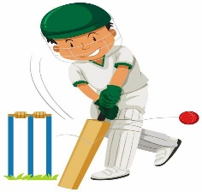 | - Dance  - Ball skills  - Running | Please remember:  - Children must wear their PE kits on Tuesdays and Fridays.  - Please listen to your children read as much as possible and sign their learning journal so that we can change their books.  - Children need a labelled water bottle in the classroom to access as and when they need a drink.  Please do not hesitate to contact me if you have any questions or need any support.  Miss Baldwin

