Year 3 - Mrs Wells  Mrs Edgar (Fridays) | Spring Term 2025
 | Who’s the Mummy?
ENGLISH  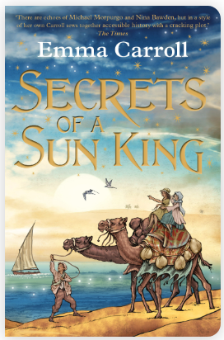 | Letter  Write a letter as the explorer, Tadeo Jones about his adventure in an Egyptian pyramid.  Non-Chronological Report  Write a report about Ancient Egypt that could be used for a history book.  Newspaper Report  Reporting on the discovery of Tutankhamun’s tomb by Howard Carter in 1922.  Travel Brochure  Create a brochure encouraging people to visit Egypt, focusing on the historical sites.  Spelling, punctuation and grammar work in Active English and Active Spelling lessons.  Daily Guided Reading activities. | 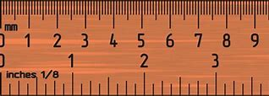  MATHS  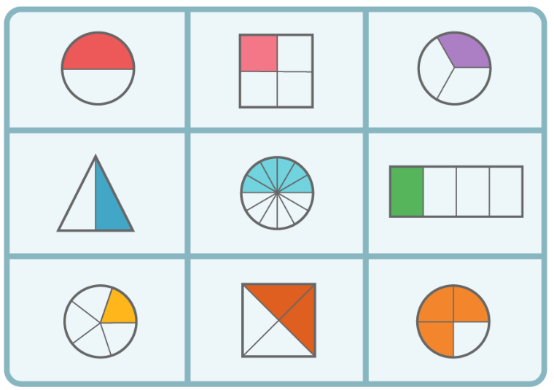 | Multiplication and Division  To multiply by a 2-digit number.  To be able to divide with a range of methods.  Length and Perimeter  To be able to measure in mm, cm and m.  To be able to compare and convert in these units.  To calculate the perimeter of a shape.  PiXL Assessments  Fractions and decimals  Cut a shape into a given fraction.  To be able to calculate a simple fraction of a number.  Calculate equivalent fractions.  To know tenths as decimals.
SCIENCE  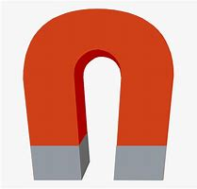  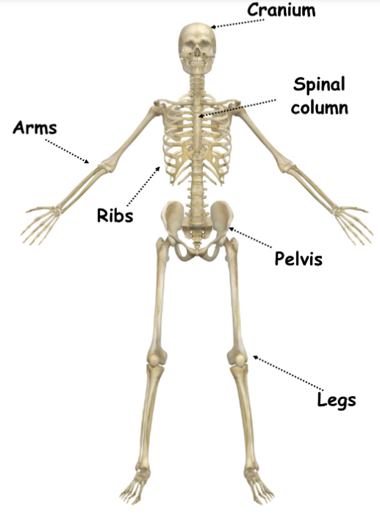  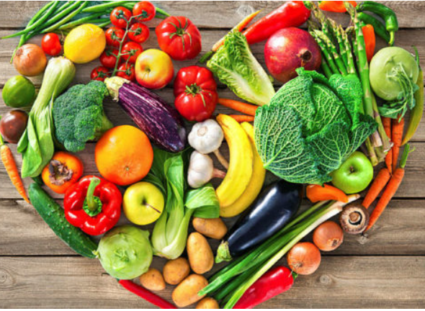 | Forces and Magnets  - compare how things move on different surfaces.  - notice that some forces need contact between two objects, but magnetic forces can act at a distance.  - observe how magnets attract or repel each other and attract some materials and not others.  - compare and group together a variety of everyday materials based on whether they are attracted to a magnet and identify some magnetic materials.  - describe magnets as having two poles.  - predict whether two magnets will attract or repel each other, depending on which poles are facing.  Animals including humans  - identify that animals, including humans, need the right types and amount of nutrition, and that they cannot make their own food; they get nutrition from what they eat.  - To know the major food groups that humans need for a balanced diet.  - identify that humans and some other animals have skeletons and muscles for support, protection and movement. | HISTORY  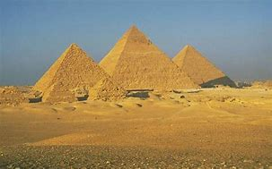 | The achievements of the earliest civilizations – an overview of where and when the first civilizations appeared and a depth study of Ancient Egypt, including:  - To know what else was happening in the world at the time of the Ancient Egyptians and what they had in common with other ancient civilisations.  - To know what the ancient civilisations needed to have to function as a city (writing, number system, laws, defence, roads, food, trade, water supply).  - To know why and who built the Great Pyramid at Giza  - To know the importance of the river Nile for trading.  - To know how religion influenced the Ancient Egyptian civilisation, including burial rituals.  - To know who Tutankhamun was and understand the religious significance of his reign.
GEOGRAPHY   | Fieldwork in Thurlby  Asking and answering fieldwork enquiries: making observations, collecting data, concluding, and presenting data. | COMPUTING  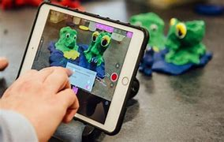 | Sequencing sounds  Creating sequences in a block-based programming language to make music.  Branching databases  Building and using branching databases to group objects using yes/no questions.
PSHE  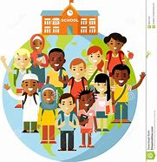   | Dreams and Goals  - Difficult challenges and achieving success  - Dreams and ambitions  - New challenges  - Motivation and enthusiasm  - Recognising and trying to overcome obstacles  - Evaluating learning processes  - Managing feelings  - Simple budgeting  Healthy me  - Exercise  - Fitness Challenges  - Food labelling and healthy swaps  - Attitudes towards drugs  - Keeping safe and why it’s important online and off-line scenarios  - Respect for myself and others  Healthy and safe choices | RE    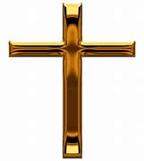 | Spring 1  Theme: Jesus’ miracles  Key Question: Could Jesus heal people? Were these miracles or is there some other explanation?  Religion: Christianity  Concept: Incarnation  Spring 2  Theme: Easter- Forgiveness  Key Question: What is ‘good’ about Good Friday?  Religion: Christianity  Concept: Salvation/Gospel
ART  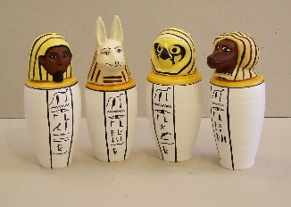 | 3D Sculpture-  - To understand the uses of canopic jars.  - To know what the designs symbolised  - To design and create a canopic jar using mod rock.  Focus artist: Belinda Fabris | 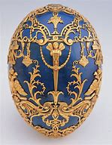  Design and Technology | Shell Structures- Designer- Carl Faberge  To explore the works of Faberge and the various designs of boxes- shapes, decorations, purposes etc  Children will design and make their own box to hold an Easter/Spring Treat
MUSIC  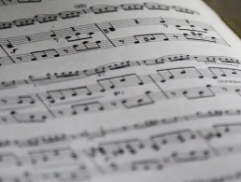  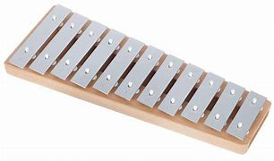 | Instrumental Unit: South Africa  Learning about the history and features of Latin America music, performing a salsa style song and playing from staff notation; performing a mini carnival using a range of performance techniques including song, dance, tuned and untuned musical instruments.  Pentatonic melodies and composition  Children will be able to:  *Match their movements to the music, explaining why they chose these movements.  *Accurately notate and play a pentatonic melody.  *Play their part in a composition confidently.  *Work as a group to perform a piece of music. | MFL  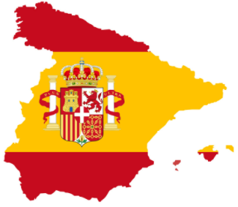 | Seasons  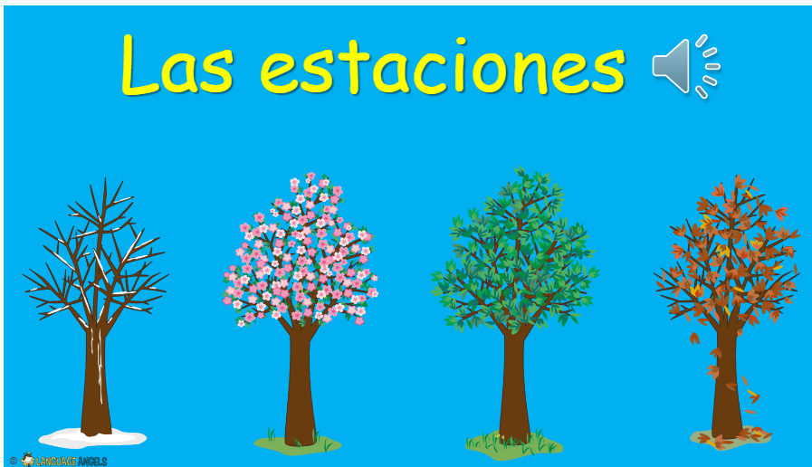  Fruits  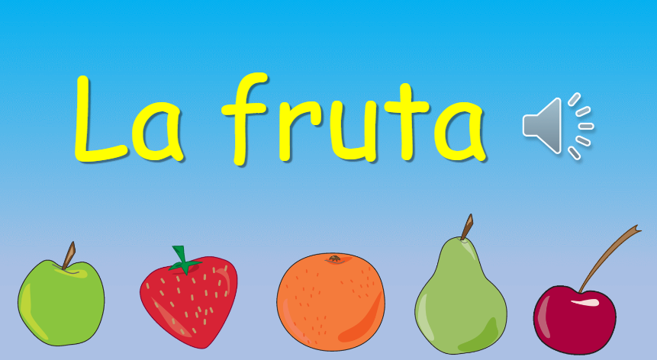
  PE | Term 3:  Outdoor games  Gymnastics  Term 4:  Tennis  Hockey | Additional information | PE days- Wednesdays & Thursdays (T3)  - Homework will be given out on Fridays and due on Wednesdays – children will be rewarded if it is handed in early.  Children will be expected to spend time reading and practising their times tables.

