Year 3-  Mr Barratt | Spring Term 2023
Year 3-  Mr Barratt | Who’s the Mummy?
English  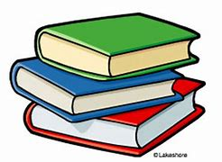 | Letter  - Writing a letter to a friend as explorer, Tadeo Jones about his adventure in an Egyptian pyramid.  Non-Chronological Report  - Writing a report on different areas of Ancient Egypt that would be designed for a history book.  Newspaper Report  - Reporting on the discovery of Tutankhamun’s tomb by Howard Carter in 1922,  Travel Brochure  - Creating a brochure about Egypt and why to visit. Focusing around the historical sites to visit. | 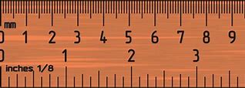  MATHS | Length and Perimeter  - To be able to measure in mm, cm and m.  - To be able to compare and convert in these units.  - They will be able to calculate the perimeter of a shape.  Money  - They will be able to count and recognise UK monetary notes and coins.  Fractions and decimals  - Cut a shape into a given fractions  - To be able to calculate a simple fraction of a number.  - Calculate equivalent fractions.  - To know tenths as decimals.  Statistics  - To be able to record information in a variety of charts.  Multiplication and division  - To be able to divide with a range of methods.  - To multiply two 2-digit numbers together.
SCIENCE  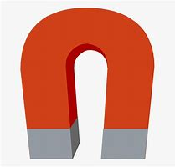 | Animals including humans  - identify that animals, including humans, need the right types and amount of nutrition, and that they cannot make their own food; they get nutrition from what they eat  - To know the different food groups and what foods are within the group. How much of each group is recommended and how to lead a healthy lifestyle.  - identify that humans and some other animals have skeletons and muscles for support, protection and movement  Forces and Magnets  - compare how things move on different surfaces notice that some forces need contact between two objects, but magnetic forces can act at a distance  - observe how magnets attract or repel each other and attract some materials and not others compare and group together a variety of everyday materials on the basis of whether they are attracted to a magnet, and identify some magnetic materials  - describe magnets as having two poles  predict whether two magnets will attract or repel each other, depending on which poles are facing | HISTORY  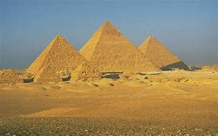 | The achievements of the earliest civilizations – an overview of where and when the first civilizations appeared and a depth study of Ancient Egypt, including:  - To know what else was happening in the world at the time of the Ancient Egyptians and what they had in common with other ancient civilisations  - To know what the ancient civilisations needed to have to function as a city (writing, number system, laws, defence, roads, food, trade, water supply).  - To know why and who built the Great Pyramid at Giza  - To know the importance of Hatshepsut an Egyptian leaders and trader  - To know the importance of the river Nile for trading.  - To know how religion influenced the Ancient Egyptian civilisation, including burial rituals  - To know who Tutankhamun was and understand the religious significance of his reign.
GEOGRAPHY  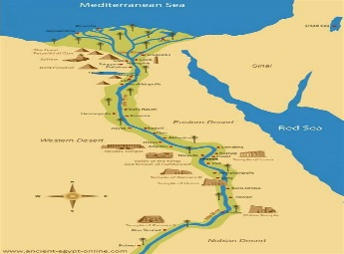 | Human geography,  Focused around the River Nile: types of settlement and land use, economic activity including trade links, and the distribution of natural resources including energy, food, minerals and water | COMPUTING  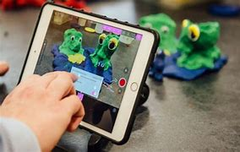 | Sequencing sounds  Creating sequences in a block-based programming language to make music  Branching databases  Building and using branching databases to group objects using yes/no questions
PSHE  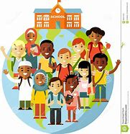 | Dreams and Goals  - Difficult challenges and achieving success  - Dreams and ambitions  - New challenges  - Motivation and enthusiasm  - Recognising and trying to overcome obstacles  - Evaluating learning processes  - Managing feelings  - Simple budgeting  Healthy me  - Exercise  - Fitness Challenges  - Food labelling and healthy swaps  - Attitudes towards drugs  - Keeping safe and why it’s important online and off-line scenarios  - Respect for myself and others  Healthy and safe choices | 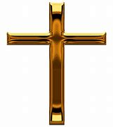  RE | Community – Christianity  How is Christian belief expressed collectively? How does Christian worship and celebration build a sense of community?  Worship and celebration. Ways in which worship and celebration engage with/affect the natural world. Beliefs about creation and natural world
ART  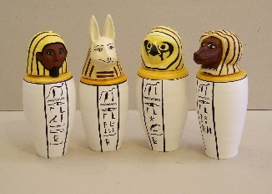 | 3D Sculpture-  - To understand the uses of canopic jars.  - To know what the designs for the jars symbolised  - To design and create a canopic jar using mod rock. | 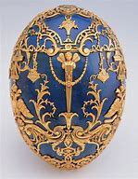  Design and Technology | Shell Structures-  Make a box to hold an Easter/Spring Treat  Designer- Carl Faberge
MUSIC  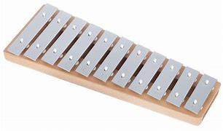 | Three Little Birds  The Dragon Song | MFL  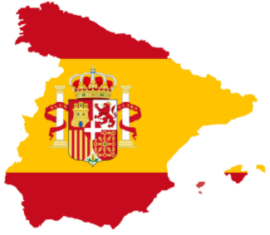 | Seasons  Fruits
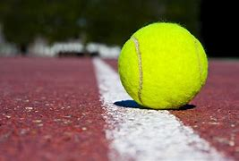  PE | Outdoor games  Cricket  Gymnastics  Tennis | Any additional information | PE days- Tuesdays and Wednesdays  Homework days- Homework to be given out on a Friday and expected in on Wednesday  Spellings- Handed out on a Monday and tested on the following Monday.

