Year 4 -  Miss Derbyshire  Mrs Norbury | Summer Term 2023
 | The Tudors
English  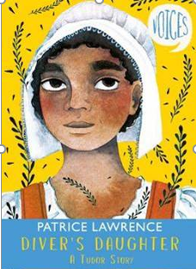      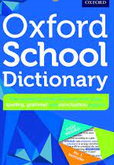 | Reading Comprehension  - Identify themes and conventions in a wide range of books  - Find and copy words to illustrate a point  - Find and copy a synonym  - Summarise paragraphs  - Identify character motivation  - Predict what might happen or how a character might respond from details stated and implied  - Improve speed when using a dictionary to check the meaning of words read  Writing  - Explore the structure and language features of a range of texts (historic fiction, explanation, character description, discussion, poetry)  - Use an increasing range of conjunctions, varying sentence structure, to write complex sentences  - Use the present perfect form of verbs in contrast to the past tense  - Accurately use inverted commas and other punctuation to write dialogue  - Use the apostrophe to show possession (singular, plural and exception words)  - Organise paragraphs around a theme  - Improve accuracy when proofreading  - Improve vocabulary choices  - Read their own writing aloud to a group or the whole class, using appropriate intonation and controlling the tone and volume so that the meaning is clear  Handwriting  - Increase the fluency legibility and consistency of their handwriting, (for example, by ensuring that the down strokes of letters are parallel and equidistant, and that lines of writing are spaced sufficiently so that the ascenders and descenders of letters do not touch)  Spelling  - Daily Active Spelling sessions which include the revision of Year 4 spelling rules, as well as the Year 3/4 common exception words  - Use the first 2 or 3 letters of a word to check its spelling in a dictionary  - Common errors e.g. when to use its or it’s, when to use your or you’re | Maths      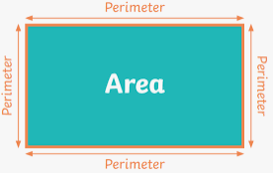 | Decimals  - Recognise tenths and hundredths  - Write tenths and hundredths as decimals and fractions  - Write tenths and hundredths on a place value chart to show their understanding of the value of each digit  - Divide 1 or 2-digit numbers by 10 and 100  - Divide 1 or 2-digit numbers by 100  - Make a whole number using tenths and hundredths  - Use place value counters and a place value chart to make numbers with up to two decimal places  - Compare numbers with decimals with up to two decimal places  - Order numbers with decimals with up to two decimal places  - Round numbers with 1 decimal place to the nearest whole number  - Write ½, ¼, ¾ as decimals  - Use concrete and pictorial representations to support with all lessons  Number and Place Value  - Compare and order numbers up to 10,000  - Round to the nearest 10, 100 or 1,000  - Count in 25s  - Negative numbers  Area and Perimeter  - Introduction to area – understand that area is the amount of space taken up by a 2-D shape or surface  - Understand that area is measured in squares and explore the most efficient method of counting squares  - Make shapes using a given number of squares Measure the perimeter of simple 2-D shapes  - Compare different 2-D shapes which have the same perimeter  - Calculate the perimeter of rectilinear shapes by counting squares on a grid  - Calculate the perimeter of a rectangle (including squares) that are not on a squared grid  - Use their knowledge of perimeter to calculate missing lengths using addition and subtraction  - Investigate possible perimeters of squares and rectangles  Time  - Years, months, weeks and days  - Hours, minutes and seconds  - Convert between analogue and digital times  - Convert to and from the 24-hour clock  - Revisit prior learning depending on areas identified in teaching and learning and through our use of assessment
SCIENCE    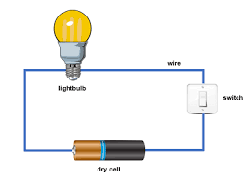 | Sound  - Identify how sounds are made, associating some of them with something vibrating  - Recognise that vibrations from sounds travel through a medium to the ear  - Find patterns between the pitch of a sound and features of the object that produced it  - Find patterns between the volume of a sound and the strength of the vibrations that produced it  - Recognise that sounds get fainter as the distance from the sound source increases  Electricity  - Identify common appliances that run on electricity  - Construct a simple series electrical circuit, identifying and naming its basic parts, including cells, wires, bulbs, switches and buzzers  - Identify whether a lamp will light in a simple series circuit, based on whether the lamp is part of a complete loop with a battery  - Recognise that a switch opens and closes a circuit and associate this with whether a lamp lights in a simple series circuit  - Recognise some common conductors and insulators, and associate metals with being good conductors | HISTORY   | The Tudors  - To know the six Tudor monarchs  - To recognise concurrent civilisations around the globe  - To know the timeline, and understand the longevity, of the Tudor era  - To know that Henry VIIs decision to break away from the Catholic Church created significant upheaval in England’s churches  - To know that Tudor monarchs had to live with the constant threat of invasion, particularly by the Spanish which led to significant military developments  - To know the importance of William Cecil, the Lord High Treasurer to Elizabeth I, and his role within the reign of Elizabeth I  - To know that William Cecil was born in Bourne, and he designed Burghley House  - To know the characteristic features of Tudor architecture with a clear focus on Burghley House  - To know that Sir Walter Raleigh was one of the most significant leaders and explorers of the era  - To know how some crimes were punished in Tudor times
GEOGRAPHY   | Locational Knowledge  - To know the position of the Prime/Greenwich Meridian and start to understand the significance of latitude and longitude | COMPUTING   | Repetition in shapes  Creating programs by planning, modifying, and testing commands to create shapes and patterns  - Programme a screen turtle  - Programme letters  - Patterns and repeats  - Use loops to create shapes  - Break things down  - Create a program  Data logging  Recognising how and why data is collected over time, before using data loggers to carry out an investigation  - Understand that data gathered over time can be used to answer questions  - Use a digital device to collect data automatically  - Understand that a data logger collects ‘data points’ from sensors over time  - Recognise how a computer can help us analyse data  - Identify the data needed to answer questions  - Use data from sensors to answer questions
PSHE     | Relationships  - Jealousy  - Love and Loss  - Memories  - Getting On and Falling Out  - Girlfriends and Boyfriends  - Celebrating My Relationships with People and Animals  Changing Me  - Unique Me  - Outside Body Changes  - Inside Body Changes  - Girls and Puberty  - Circles of Change | RE   | Buddhism  What is the best way for a Buddhist to lead a good life?  - Discuss good choices that we make in life and what the consequences could be if we don’t make a ‘good choice’  - Decide on 8 ways that would help the class feel even more safe and happy – why have these been chosen?  - Review the Noble Eightfold Path and compare to the 8 things the class have decided on – how are they similar? How are they different?  - In groups, explore one of the eight folds to find out about it in more detail and share this through drama, quizzes, games, stories, PPT  Christianity – Prayer and Worship  Do people need to go to church to show they are Christians?  - Class discussion about special places in children’s lives  - Who has been to church before? Why might you go there?  - Learn about John the Baptist as an important figure in the Bible  - Discuss views on adults and children being baptised  - Understand about Holy Communion which takes place in a church  - What happens in worship? Understand about different styles of worship  - How do Christians live their lives from day to day?  - Develop an understanding about Jesus’ teachings about worship
ART  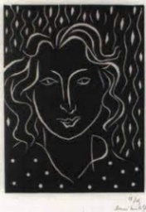 | Lino Printing  - To observe, interpret and evaluate a range of Tudor portraits  - To develop knowledge of the process of lino printing and its distinctive characteristics  - To create a lino block inspired by Tudor portraits  - To develop and apply the process of lino printing to successfully print a lino block  - To evaluate their own and others’ work: comparing ideas, methods and approaches in their own and others’ work and say what they think and feel about them | Design and Technology  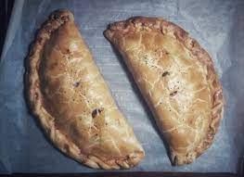 | Design and make a Cornish pasty  - Understand seasonality of vegetables and herbs  - Taste a range of savoury snacks and record results based on their sensory evaluation  - Select ingredients and equipment to cook an authentic Tudor Cornish pasty  - Work in a safe and hygienic manner, particularly when chopping and dicing vegetables  - Evaluate the finished food product, highlighting positive comments and areas for development
MUSIC   | Term 5  - Theme song: Blackbird by The Beatles – a song about civil rights  - Learning will involve discussing the structure of the song and beats to the bar  - Listen to the song and create our own actions and body percussion to match the lyrics  Term 6  - Theme – Reflect, Rewind and Replay  - Learn about the History of Music and introducing the Language of Music  - The focus will be on listening to and appraising Classical music, playing instruments along with the song, composition and improvisation | MFL   | Classroom  - Recognise and repeat from memory simple classroom objects and use the correct gender  - Say what they have and do not have in their pencil case  - Recognise and respond to simple classroom commands and praise  Family  - Say the nouns in Spanish for members of their family  - Tell somebody in Spanish the members and age of a fictitious, historical or television family as a model to present and practise family vocabulary  - Continue to count, reaching 100, to enable students to say the age of various family members  - Understand the concept of mi and mis in Spanish
PE   | Athletics  - Know a range of track and field events in athletics  - Use and develop running, catching and throwing skills  - Learn about sprinting techniques that need to be applied in athletic events  - Know how to complete relays, including changing the baton from one runner to the next  - Learn how to complete a standing triple jump  - Develop accurate skills when throwing a javelin  - Complete a Pentathlon in small groups  Rounders and Kwik Cricket  - Develop catching and throwing over a variety of distances  - Develop ability to strike a ball with accuracy  - Understand the rules for playing a fair game  - Consider the safety aspects when playing a team game  - Understand the importance of teamwork and to apply this understanding  Swimming  - Swim competently, confidently and proficiently over a distance of at least 25 metres  - Use a range of strokes effectively [for example, front crawl, backstroke and breaststroke]  - Perform safe self-rescue in different water-based situations | Additional Information | PE days  - Term 5 Fridays (term 6 to be confirmed)  - Swimming is on a Tuesday from 18.04.23 up to and including 27.6.23  Homework Days  - English is set on a Wednesday and is due in on the following Monday  - Maths is set on a Friday and is due in on the following Thursday  Diary Date  Year 4 class trip – Tudor day at Burghley House on Wednesday 24th May.

