Year 3-  Mr Barratt | Summer Term 2022
 | The Groovy Greeks
English   | Myths  - Reading Mesdussa and then creating our own myth with a made up mythical creature.  Fable  - Look at a number of different fables in order to understand what makes a fable.  - Writing our own fable with an important message.  Script  - After learning about ancient Greek theatres, looking at scripts.  - Turning a well known story into a script.  Non-Chronological Report  - Writing a Non-Chronological report about Ancient Greek Gods | 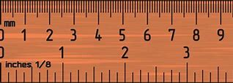  MATHS | Properties of Shapes  - What are the names of the 2-D and 3-D shapes?  - What are each of their different properties?  - How can we tell them apart?  - Different types of angles  - Being able to tell what type of angle it is.  Date and Time  - Being able to confidently tell the time.  - Understand a calendar.  - Understanding the days in a month.  Fractions and decimals (Recap)  - Cut a shape into a given fractions  - To be able to calculate a simple fraction of a number.  - Calculate equivalent fractions.  - To know tenths as decimals.  Measuring (Recap)  - Be able to confidently measure with a ruler.  - To understand what a perimeter is.  - To be able to find the perimeter of a shape.
SCIENCE   | Plants  - Growing our own plants in the classroom to see the different criteria for what a plant will need to grow and what happens if they are not given these.  - The know the lifecycle of a plant.  - To understand the functions of the different parts of a plant. For example, the roots or the stem.  Light  - To know how light works alongside our eyes to help us see.  - To know what a light source is.  - To know what materials let light through and how much they do let through.  - Design our own shadow puppets to go along side our scripts from English earlier in the term. | HISTORY  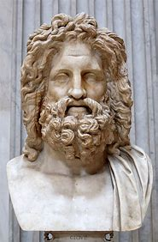 | The Ancient Greeks  - Understanding what a civilisation is.  - Why was Greece split up into city states?  - A look into Greece’s war tactics and why they were so good.  - What made Alexandre the Great so great?  - Ancient Greek life and its influences on modern day.  - To know about the Greek Olympics.  - How has Ancient Greek politics shaped our lives today?
GEOGRAPHY  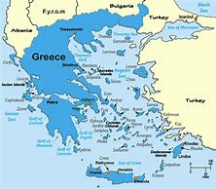 | To know where Greece is and why people would visit it.  Understanding the culture in Greece and how it was inspired by the Ancient Greeks. | COMPUTING   | Images and Texts  Looking through why both imagery and text can be so powerful and where it is appropriate to use it,  Also looking at how to use them on the ipads.
PSHE | Relationships  - Our families  - Our friendships  - The challenges they come with.  - Important decision making.  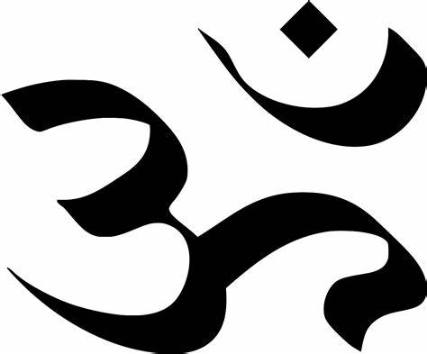  - Helpful suggestions to people who are in scenarios which may be challenging.  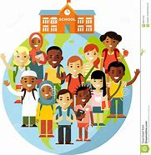  Changing Me  - Learning about human babies and how they grow and develop.  - The changes that we will go through in our lives, both on the inside and outside.  - The different stereotypes of a family and what any family can realistically look like. | RE | Hinduism- Who is Brahman?  To understand the wide range of Hindu Gods and the general beliefs around them.  Who is Brahman and how is it that Brahman is made up of the other gods within the religion and the Hindu’s aspirations in life which are aimed towards pleasing Brahman.  Hinduism- Pilgrimage to the River Ganges.  What is a pilgrimage?  Why do Hindus go on a long journey to the River Ganges and what do they believe they gain from the experience?  Would this experience of visiting the river Ganges feel special to a non-Hindu person?
ART  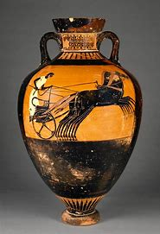 | Pottery  - To design a clay pot inspired by Ancient Greece.  - To create and paint on a design to finish off our modern day pots. | Design and Technology  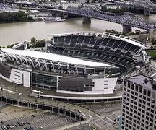 | CAD-  Designing and creating an ancient Greek stadium using a Computer Aided Designing programme.  Also, creating a podium for an Olympic games.
MUSIC  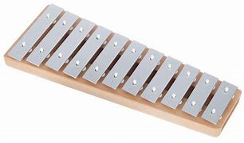 | Bringing us together- Joanna Mangona and Pete Readman.  This is a more upbeat disco style piece of music around friendship, peace, hope and unity.  Reflection- This is a chance for us to go back and reflect on all of the different styles of music which we have learnt about this school year. | MFL  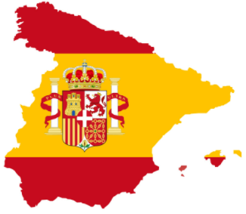 | Me Presento (Presenting myself)- general greetings in Spanish.  La Familia (The family)- Learning the names for different family members in Spanish.
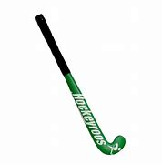  PE | Swimming  Hockey- Knowing the basic skills in hockey.  Being able to pass and shoot the ball.  Athletics- Trying a range of athletic events and relating this to the Greek Olympics. | Any additional information | PE days- Tuesdays (swimming) and Wednesdays  Homework days- Homework to be given out on a Friday and expected in on Wednesday.

