Year 1 Autumn Term 2022
Year 1  Miss Pinto | Term 1: All about Thurlby  Term 2: Pastimes
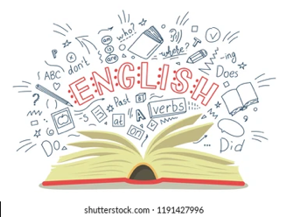  ENGLISH | - Reading: whole class, group and individual  - Phonics: Read Write Inc.  - Writing: fiction and non-fiction  - Elephant stories  - Toy themed stories  - Christmas stories  - Poems and rhymes  - Letter formation/handwriting | 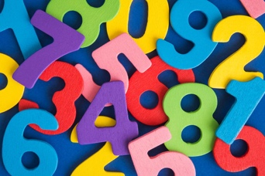  MATHS | Number: Place Value within 10  Number: Addition and Subtraction (within 10)  Geometry: Shape  Number: Place Value (within 20)
SCIENCE  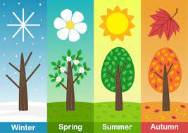 | Seasonal Changes  - observe changes across the four seasons  - observe and describe weather associated with the seasons and how day length varies.  Everyday Materials  - distinguish between an object and the material from which it is made  - identify and name a variety of everyday materials, including wood, plastic, glass, metal, water, and rock  - Identify and name a variety of familiar materials, e.g. wood, plastic, glass, metal, water, rock, brick, paper, fabrics, elastic and foil.  - Recognise that the same material can appear very different – but it is still the same material, e.g. a plastic sandwich bag and plastic lunch box, a wooden toy and a wooden table top. | 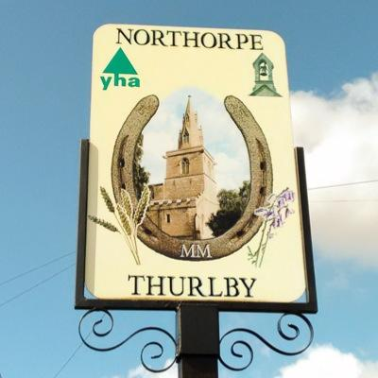  HISTORY | Own timeline and family tree  Our village in the past  - The understanding of the world: everyday language about the passing of time, ordering and sequencing familiar events.  - To create a timeline to represent one day.  - Recounting details from the past.  Changes beyond living memory  - Pastimes through the ages.  - To know that objects have changed over time.  - Where the artefacts / images of everyday life fit on a timeline  - Ask questions about the past using artefacts/pictures as a prompt.  - There are similarities and differences between the way of life now and in the past within the family home.  - Understanding about the past in different ways i.e. role play, drawing, writing, talking.
GEOGRAPHY  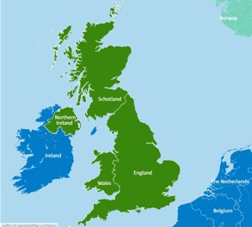 | Human and Physical geography  - identify seasonal and daily weather patterns in the United Kingdom and the location of hot and cold areas of the world in relation to the Equator and the North and South Poles  - use basic geographical vocabulary to refer to: key human features, including city, town, village, factory, farm, house, office and shop  Geographical skills and fieldwork  - use world maps, atlases, and globes to identify the United Kingdom and its countries, as well as the countries, continents and oceans  - use simple compass directions (North, South, East and West) and locational and directional language [for example, near and far; left and right], to describe the location of features and routes on a map use aerial photographs and plan perspectives to recognise landmarks and basic human and physical features in Thurlby; devise a simple map; and use and construct basic symbols in a key  - use simple fieldwork and observational skills to study the geography of their school and its grounds and the key human and physical features of its surrounding environment  Changes beyond living memory  - Pastimes through the ages | 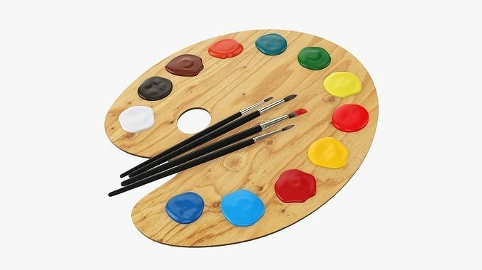  ART | Self-Portrait  - Colour mixing wheel  - To know how to create different lines, marks and tones using a dry media.  - Range of artists, craft makers and designers, describing the differences and similarities between different practices and disciplines, making links to their own work.  - Style of David Hockney.  - Drawing and painting to share their ideas, experience and imagination.  2D Modelling  - Create a clay tile  - Ceramic artists- Hilke Macintyre/ John Beasley  - Primary colours  - Using their sketchbook for collecting ideas.  - Adding materials to paint creates different textures  - different objects create different patterns and textures when rubbing/rolling.
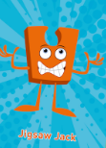  PSHE | Being me in My World  - Feeling special and safe  - Being part of a class  - Rights and responsibilities  - Rewards and feeling proud  - Consequences  - Owning the Learning Charter  Celebrating Difference  - Similarities and differences  - Understanding bullying and knowing how to deal with it  - Making new friends  - Celebrating the differences in everyone | 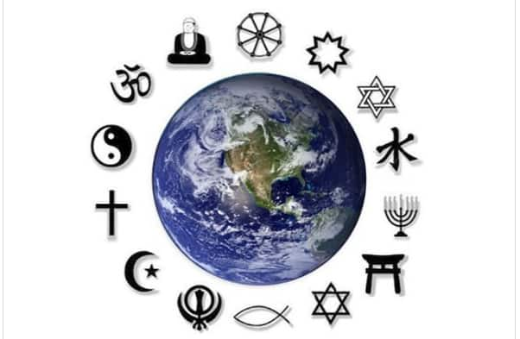  RE | God – Christianity  - What do Christians learn and understand about God through Old Testament Bible stories? (For example, Moses, Abraham, Jonah)  - What do stories in the New Testament tell Christians about Jesus?  Community – Christianity  - What do Christians do to express their beliefs?  - Which celebrations are important to Christians?  - What are the key practices associated with these celebrations and what do they tell us about beliefs about God, humans and the world?
  COMPUTING | Technology Around us  - Recognising technology in school and using it responsibly  - Moving objects on a screen.  - Creating a picture.  Digital Painting  - Choosing appropriate tools in a program to create art, and making comparisons with working non-digitally  Ipaintz on the iPads. | 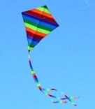  Design and Technology | Templates and Joining  - Evaluate a range of products, design and learn the skills to make a kite  - To make a Carp Kite.  - Investigate and evaluate existing kites while comparing fabrics, joining techniques, finishing techniques and fastenings used.
  MUSIC | Listening, singing, rhythmic response, instrumental accompaniment and performance:  - Hey you!  - Rhythm In the way we walk and Banana Rap | 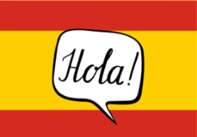  MFL SPANISH | Animals  - Name and recognise up to 10 animals in Spanish  - Musical instruments.
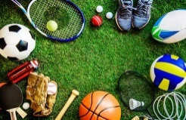  PE | Dance: The seasons  - Multi-skills  - Control as they travel, jump and spin.  - Identify which part of a performance may need to be improved.  - Keep to the beat of the music when performing.  Gymnastics  - Multi-skills  - Master running, jumping, throwing, and catching.  - Master developing balance, agility, and co-ordination (applying these in a range of activities)  - Participate in team games, developing simple tactics for attacking and defending.  - Perform dances using simple movement patterns.

Welcome back to the new term. I am really looking forward to meeting you all and starting our new adventures together!
Please remember:
- Children must wear their PE kits on Tuesdays and Thursdays
- Please listen to your children read as much as possible and sign their learning journal so that we can change their books
- Children need a labelled water bottle in the classroom to access as and when they need a drink
- Spellings will go home in their learning journals every Friday for a test the following week
Please do not hesitate to contact me if you have any questions or need any support.
Miss Pinto

