Year 1  Miss Pinto | Summer Term 2023
Summer 1: The World at Our Feet.

Summer 2: All at Sea!
ENGLISH  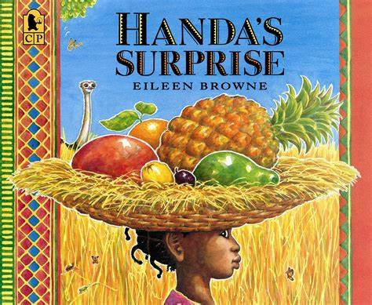 | - Reading: whole class, group and individual  - Phonics: Read Write Inc.  - Writing: fiction and non-fiction(letters, lists, fact file, story writing, invitations, news)  - ‘Letter formation/handwriting  - Stories from Africa: Handa’s surprise, Amazing Grace and The Water Princess. The Magic Faraway Tree.  - The Tiny Seed linked to science learning.  - The ‘Lighthouse Keeper’ stories.  - The ‘Snail and The Whale’ story. | MATHS  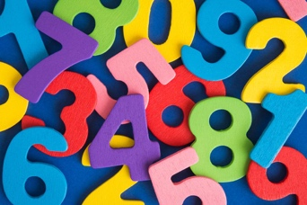 | - Measurement: Weight and volume: (heavy/light, heavier than, lighter than) (full/empty, more than, less than, half, half full, quarter)  - Number: Multiplication and Division: solve one-step problems involving multiplication and division, by calculating the answer using concrete objects, pictorial representations, and arrays (with support)  - Number: Fractions: recognise, find, and name half and a quarter of an object, shape, or quantity  - Number: Place Value (within 100): count to and across 100, read and write numbers to 100 in numerals, identify and represent numbers using objects and pictorial representations.  - Measurement: Money: recognise and know the value of different denominations of coins and notes.  - Geometry: Position and Direction: describe position, direction, and movement, involving whole, half, quarter and three-quarter turns Time (ongoing learning throughout the year)
SCIENCE  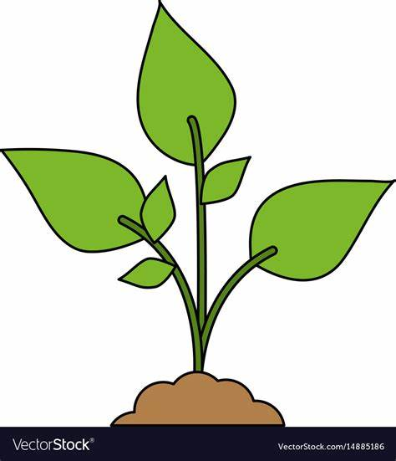  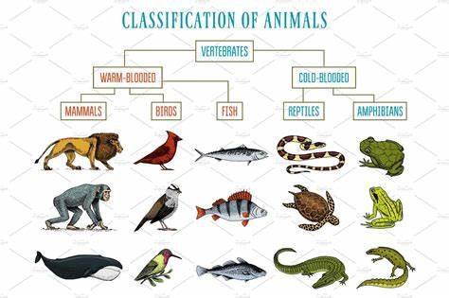 | Plants  - identify and name a variety of common wild and garden plants, including deciduous and evergreen trees  - identify and describe the basic structure of a variety of common flowering plants, including trees.  Animals  • Identify and name a variety of common animals including fish, amphibians, reptiles, birds, and mammals  • describe and compare the structure of a variety of common animals (fish, amphibians, reptiles, birds, and mammals, including pets)  • identify and name a variety of common animals that are carnivores, herbivores, and omnivores  Seasonal Changes (ongoing throughout the year) • observe changes across the four seasons • observe and describe weather associated with the seasons and how day length varies | HISTORY  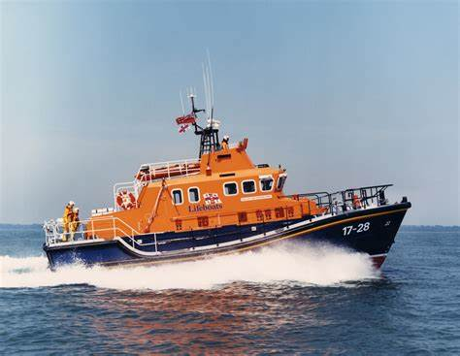  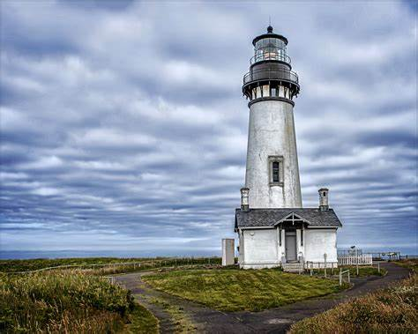 | The RNLI, lifeboats, and lighthouses  - What is the RNLI?  - Where are our nearest lifeboat stations?  - What is the purpose of a lighthouse?  - How have lifeboats and lighthouses changed over time?  Seaside holidays  - How have seaside holidays changed over time? (Travel, entertainment, accommodation, clothing, food)  The Life of Grace Darling  - Who was Grace Darling?  - The events of 7th September 1838  - Why is she remembered today
GEOGRAPHY  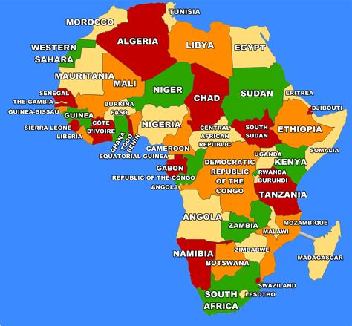  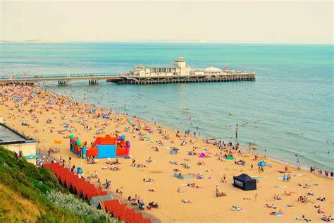 | Africa/Kenya  • To know where Africa is on a world map and where the UK is in relation. Africa is a continent which is made up of 54 different countries and each country has its own flag. • To know that the biggest country in Africa is Algeria and the smallest country is Gambia.  • To know that Kenya is a country in East Africa and that its capital in Nairobi  • To know that Naivasha is a market town in Kenya which is a popular tourist resort  • To know that wildlife tours are very popular in Naivasha, and tourists go on safari to see the ‘Big Five’ animals: rhino, lion, leopard, cape buffalo and elephant  • To know that farming is important to Naivasha, especially growing flowers (compare with Lincolnshire). Compare Nairobi and Naivasha with Thurlby and Bourne • To know that there are different groups of people and that Maasai and Luo tribes live in Kenya. They are farmers. Compare with life of child in the UK.  • To know and locate seaside resorts around the UK on a map and know that Skegness is in Lincolnshire and that Hunstanton is in Norfolk  • To use digital maps and photographs to describe the features for each location  • To know key PHYSICAL features found by the sea: beach, cliff, coast  • To know key HUMAN features found by the coast: port, harbour, and shop  • To know that the coast has many different uses: leisure, fishing, tourism  • Conduct simple fieldwork at Hunstanton | COMPUTING   | Digital Writing:  Using a computer to create and format text, before comparing to writing non-digitally.  Programming Animations:  Designing and programming the movement of a character on screen to tell stories.
PSHE  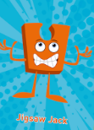 | Relationships:  • Families  • Making Friends  • Greetings  • People Who Help Us  • Being My Own Best Friend  • Celebrating My Special Relationships Changing Me  • Life Cycles  Changing Me  • My Changing Body  • Boys’ and Girls’ Bodies  • Learning and Growing  • Coping With Change | 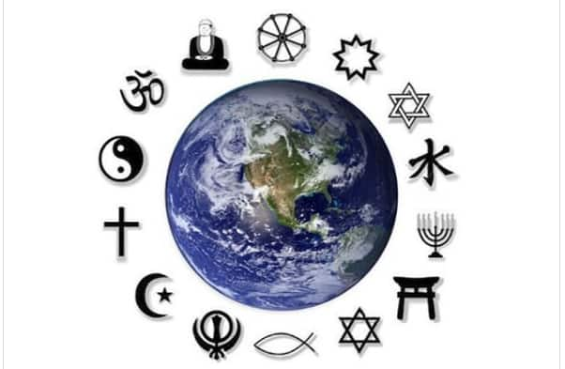  RE | Shabbat:  Key Question: Is Shabbat important to Jewish children? Religion: Judaism  Rosh Hashanah and Yom Kippur  Key Question: Are Rosh Hashanah and Yom Kippur important to Jewish children?  Religion: Judaism
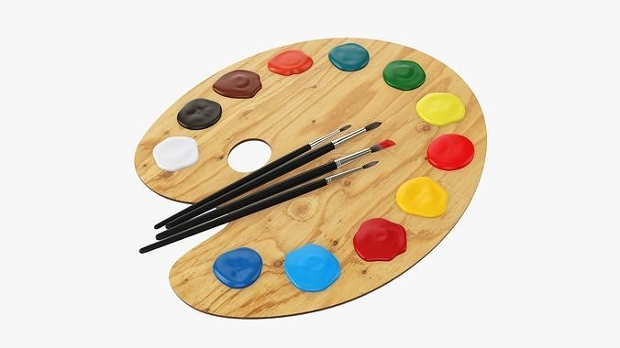  ART | Sculpture:  • Individual sculpture based on an African animal Focus artists/artwork.  • Sophie Taeuber-Arp  • Pablo Picasso | Design and Technology  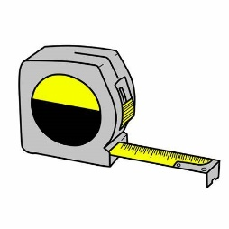 | Levers and Sliders:  • Design and make a moving scene, based on the sea  • Focus Designer: Maike Beiderstadt
  MUSIC | Listening, singing, rhythmic response, instrumental accompaniment, and performance:  • Your Imagination  • Reflect, Rewind and Replay |   MFL | - Animals – names of common animals  - • Shapes – names of familiar shapes  - • I can……
PE  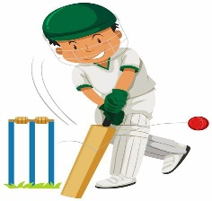 | • Gymnastics  • Tennis  • Team Games  • Athletics | Please remember:  - Children must wear their PE kits on Tuesday and Friday.  - Please listen to your children read as much as possible and sign their learning journal so that we can change their books.  - Spellings will go home in their learning journals every Friday for a test the following week.  Please do not hesitate to contact me if you have any questions or need any support.  Miss Pinto

