Year 4 -  Miss Derbyshire  Mrs Norbury | Autumn Term 2022
Year 4 -  Miss Derbyshire  Mrs Norbury | The Romans
English  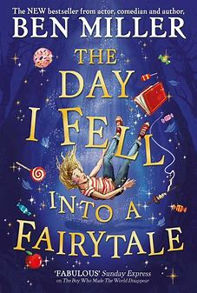    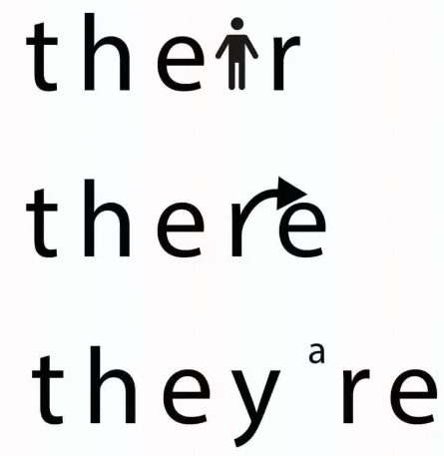 | Reading Comprehension  - Skim and scan texts  - Retrieve precise information from a range of texts  - Continue to develop inference skills  - Identify how language, structure, and presentation contribute to meaning  Writing  - Explore the structure and language features of a range of texts (Dilemma Stories, Instructions, Story Portals, Non-Chronological Reports, Descriptive Settings)  - Use appropriate fronted adverbials (time, manner and place)  - Use the comma after fronted adverbials  - Use a range of conjunctions to write complex sentences  - Use expanded noun phrases modified by adjectives and nouns  - Use inverted commas and other punctuation to indicate direct speech  - Use the apostrophe to show possession (singular and plural)  - Edit and improve own writing  Handwriting  - Use the diagonal and horizontal strokes that are needed to join letters and understand which letters, when adjacent to one another, are not joined  Spelling  - Year 3/4 common exception words  - Use further prefixes and suffixes and understand how to add them  - Homophones e.g., there, their and they’re | Maths  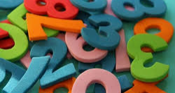    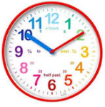 | Number and Place Value  - Represent numbers to 10,000  - Round numbers to the nearest 10 and 100  - Partition numbers to 10,000  - Number line to 10,000  - Find 1, 10, 100, 1,000 more or less  - Roman Numerals  Geometry  - Know and recognise acute, right and obtuse angles  - Compare and order angles  - Types of triangles and quadrilaterals  - Lines of symmetry  Addition and Subtraction  - Add and subtract up to 4-digit numbers using formal written methods  - Apply written methods to different types of real-life problems  Measures  - Pounds and pence, including converting from one to another  - Ordering money  - Add and subtract money, finding change  - Use written methods involving amounts of money  - Telling the time to the nearest minute using am/pm  - 24-hour clock  - Hours, minutes and seconds  - Years, months, weeks and days  - Analogue to digital in 12-hour and 24-hour  Multiplication and Division  - Multiplying and dividing by 10 and 100  - Multiply by 1 and 0, divide by 1 and itself  - Multiply and divide by all multiplication facts up to 12x12  - Apply knowledge to problem solving questions
SCIENCE  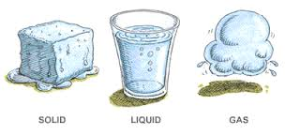  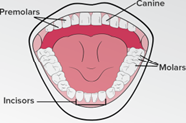 | State of Matter  - To compare and group materials together, according to whether they are solids, liquids or gases  - To observe that some materials change state when they are heated or cooled, and measure or research the temperature at which this happens in degrees Celsius (°C)  - To identify the part played by evaporation and condensation in the water cycle and associate the rate of evaporation with temperature.  Animals including humans  - To describe the simple functions of the basic parts of the digestive system in humans  - To identify the different types of teeth in humans and their simple functions | HISTORY  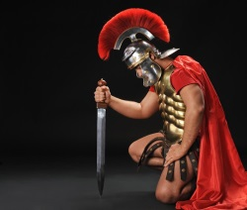 | The Roman Empire and its impact on Britain  Key Question: Which of the Roman achievements had the most significant impact on Britain?  - To develop a chronological awareness of the Roman era  - To understand why Julius Caesar attempted to invade Britain  - To understand why the Roman army was so powerful  - To learn about Claudius’ successful invasion and conquest of Britain  - To find out about the life of Boudicca and her significance in British history  - To learn about like in a Roman town and the beliefs the Romans held
GEOGRAPHY   | Locational Knowledge  Locate the world’s countries, using maps to focus on Europe’s (including the location of Russia) countries and major cities  - To know and locate on a map the countries which became part of the Roman Empire  - To understand why Rome became the centre of the empire (physical characteristics)  - To know that they (the pupils) live in Lincolnshire and to learn of evidence, within Lincolnshire, that the Roman lived here too  Geographical skills and fieldwork  Four grid references, symbols and key (including the use of Ordnance Survey maps) to build their knowledge of the United Kingdom and the wider world  - To learn about British Roman sites, such as Hadrian’s Wall and locate them on a map using simple grid references | COMPUTING  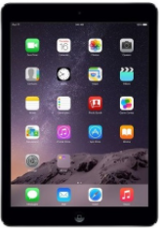 | The internet  Recognising the internet as a network of networks including the WWW, and why we should evaluate online content.  - Understand what the internet is made of  - How information is shared  - What a website is and who owns the web  - Recognise that there is some inaccurate information on the internet  Audio editing  Capturing and editing audio to produce a podcast, ensuing that copyright is considered  - Digital recording  - Recording sounds  - Creating a podcast  - Editing digital recordings  - Evaluating podcasts
PSHE  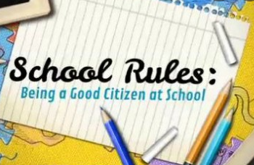 | Being me in My World  - Being part of a class team  - Being a school citizen  - Rights, responsibilities and democracy (school council)  - Rewards and consequences  - Group decision-making  - Having a voice  - What motivates behaviour  Celebrating Difference  - Challenging assumptions  - Judging by appearance  - Accepting self and others  - Understanding influences  - Understanding bullying  - Problem-solving  - Identifying how special and unique everyone is  - First impressions | RE  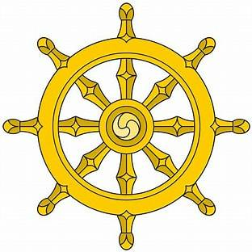  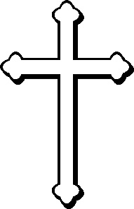 | Buddhism – The Life of the Buddha  Key Question: Is it possible for everyone to be happy?  - Learn about the life of the Buddha and explore how he tried to be happy and stay happy  - What makes you happy?  - Listen to various songs and discuss the feelings felt when listening to them  - Would being rich always make you happy?  - Listen to and discuss the story about ‘The Life of the Buddha’  - What did the Buddha realise under the Bodhi tree?  Christianity – Christmas  Key Question – What is the most important part of the Nativity story for Christians today?  - Understand the symbolism in the Christmas story and think about what the different parts mean to Christians today  - Know the meaning of Christingle and think about what Christmas means to Christians  - Design and make something which symbolises Christmas to Christians  - Be introduced to the concept of ’Incarnation’
ART  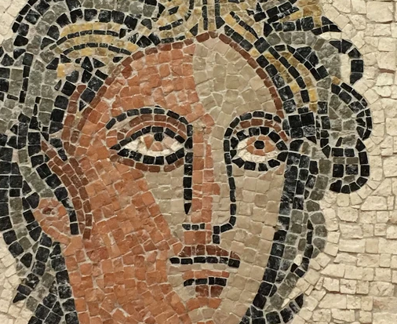 | Tiles Mosaic- 2D sculpture  - To understand how mosaics were used in Roman times  - To make a symmetrical mosaic using ICT and paper ‘tesserae’  - To plan and design a mosaic tile  - To make a simple mosaic using the direct method of mosaicking  - To compare ideas, methods and approaches in their own work and others’ work | Design and Technology   | 2D Shape to 3D product-  - Design and make a purse, understanding that a purse is made from a 2D net  - Explore different fastenings for a purse  - Practise different sewing stitches to use for joining a purse together  - Design own purse to meet a given criteria and create a prototype of it  - Use appropriate materials and techniques to make their final design  - Evaluate the effectiveness of their product
MUSIC   | Mamma Mia  - Children will learn to sing Mamma Mia and play a glockenspiel accurately to the beat of the music  - Also, they will listen and practise singing other well-known songs by ABBA, such as Dancing Queen  Glockenspiel Stage 2  - Learn to sing simple songs which children will play the glockenspiel along to  - Children will start learning to read music on a stave which they will play on the glockenspiels | MFL  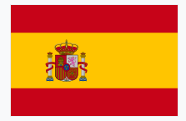 | Phonetics 1 and 2  - Learn essential Spanish sound patterns / phonemes so that children will improve their Spanish pronunciation and be able to read Spanish with improved accuracy  Fruits  - Learn the names and spelling of common fruits  - Be able to say which fruits are liked or disliked
PE   | Roman Dance  - To use the space provided to the maximum potential  - To combine flexibility, techniques and movements to create a fluent sequence  - To move appropriately and with the required style in relation to the stimulus  - To move to the beat accurately  Football  - Learn the different skills of dribbling, passing and shooting  - Know how to attack and defend during a game  - Play mini games of football to apply the skills they have learnt  Hockey  - To dribble, pass and shoot a ball using a hockey stick  - To understand how to defend and attack safely  - To apply skills learnt into a mini game situation  Gymnastics  - Different methods of travelling over, along and under in a given space on and off the apparatus  - Balancing on different parts of the body – floorwork and on the apparatus  - Symmetrical and asymmetrical balances, jumps and rolls  - Create a sequence to apply all skills practised | Additional Information | PE days  - Term 1: Monday and Friday  - Term 2: Information will be sent out via parent mail.  Homework Days  - English is set on a Wednesday and is due in on the following Monday  - Maths is set on a Friday and is due in on the following Thursday  - Spelling test on Fridays

