Year 5- Mrs Wells | Summer Term 2023
 | The Resourceful Rainforest
English  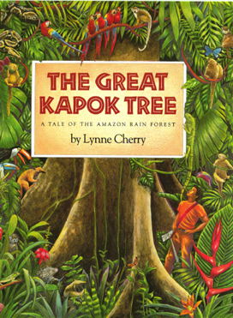  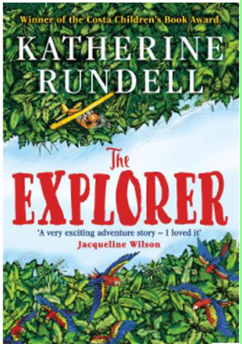 | Class novels: ‘The Great Kapok Tree’ – Lynne Cherry, ‘The Explorer’ – Katherine Rundell  - Setting Description  - Balanced Argument- deforestation  - Dialogue/speech  - Role play  - Information Text  - Playscript  - Spelling, punctuation and grammar work in Active English lessons | Maths   | Fractions, Decimals and Percentages  - Rounding decimals  - Addition and subtraction of decimals  - Percentages of amounts  - Percentages as fractions and decimals  Geometry  - Drawing, measuring and calculating angles.  - Properties of shapes  - Reflection, translation and lines of symmetry  PiXL Assessments  Measure  - Recap of converting between metric and imperial units of measure
SCIENCE  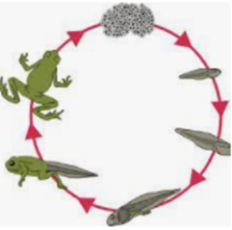 | Living Things and Their Habitats  - Describe the differences in life cycles of a mammal, an amphibian, an insect and a bird.  - Describe the life process of reproduction in some plants and animals.  Animals, including Humans  - Describe the changes as humans develop to old age. | Geography  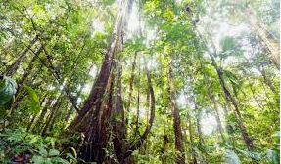 | Our Geography work will be linked to our work in English lessons.  We will revise our knowledge of continents and their physical and human features.  We will learn about the human influence on the land regarding deforestation, global warming and pollution.  We will also explore life cycles in the tropical rainforests.
 | Human and physical geography  Describe and understand key aspects of:  physical geography:  - climate zones, biomes(rainforests) and vegetation belts  - Compare rainforest with temperate forest of North America  human geography:  - types of settlement and impact of land use within the rainforest, economic activity including trade links, and the distribution and destruction of natural resources including energy, food, minerals and water. | COMPUTING   | Selecting in physical computing  Exploring conditions and selection using a programmable microcontroller  Flat-file databases  Using a database to order data and create charts to answer questions
PSHE     | Relationships  Children will compare different types of friendships and the feelings associated with them. They will be able to explain how to stay safe when using technology to communicate with friends and to resist peer pressure.  Changing Me  Children will be able to explain how boys and girls change during puberty and why looking after themselves physically and emotionally is important. They will also be able to summarise the process of conception. | RE     | Religion – Sikhism  Theme: Prayer and Worship  Key Question: What is the best way for a Sikh to show commitment to God?  Religion – Christianity  Theme: Beliefs and Practices  Key Question: What is the best way for a Christian to show commitment to God?
ART  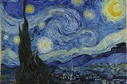 | Artists in focus- Van Gogh and Nixiwaka Yawanawa.  Children will learn the processes that Van Gogh used to paint The Starry Night- linear strokes, cross hatching, making outlines, adding fine details.  They will then study the rainforest artwork of Nixiwaka Yawanawa before creating their own artwork based on the rainforest using oil pastels. | Design and Technology   | Computer Aided Design and Frame Structures  Design a house suitable for living in a rainforest, on the computer programme TinkerCad.
MUSIC  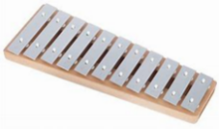   | All the learning is focused around one song: Term 5: Dancing in The Street- Martha and the Vandellas  As well as learning to sing, play, improvise and compose with this song, children will listen and appraise other songs from the Motown era.  Term 6: Reflect, Rewind and Replay  This Unit of Work consolidates the learning that has occurred during the year. All the learning is focused around revisiting songs and musical activities. | MFL   | My Home- Mi Casa  - Questioning and answering  - Do you live in a house or apartment? Where do you live?  - The rooms of the house- bedroom, bathroom, kitchen etc  Clothes  - Repeat and recognise the vocabulary for a variety of clothes in Spanish.  - Use the appropriate genders and articles for these clothes.  - Use the verb LLEVAR in Spanish with increasing confidence.
PE   | Cricket  Team Games (rounders)  Swimming – Terms 5 and 6  Athletics |  | Swimming kit on Tuesdays  - Homework will be given out on Fridays and due in on Wednesdays – children will be rewarded if it is handed in early.

