Year 2- Miss Bright  Mrs Henson  Mr Moutrey | Autumn Term 2022
Location, Location, Location! Autumn 1
Remembering Heroes and Heroines Autumn 2
English   | ‘The Boy Who Grew Dragons’ by Andy Shepherd  - Work linked to castles and dragons  - Analysing example texts  - Editing and improving work  - Studying a variety of fiction, non-fiction and poetry text types  ‘Owen and the Soldier’ by Lisa Thompson  - Work linked to Remembrance and Florence Nightingale  - Analysing example texts  - Editing and improving work  - Studying a variety of fiction, non-fiction and poetry text types | Maths  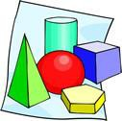 | - 2D and 3D shape  - Place value to 100  - Counting in 2s, 5s and 10s  - Place value to 100  - Addition and subtraction to 100  - Time  - Length
SCIENCE  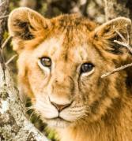 | Animals Including humans  - notice that animals, including humans, have offspring which grow into adults  - find out about and describe the basic needs of animals, including humans, for survival (water, food and air)  Animals Including humans  describe the importance for humans of exercise, eating the right amounts of different types of food, and hygiene. | HISTORY  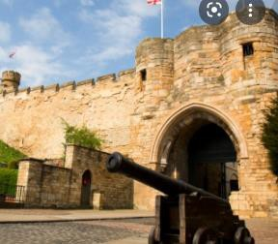 | Compare aspects of life in different periods- Lincoln Castle William the Conqueror (First Norman castle) and Windsor Castle (Queen Victoria)  Events beyond living memory and Significant Individuals-  WW1 heroes and Armistices Day Florence Nightingale, Mary Seacole

GEOGRAPHY   | Geographical skills and fieldwork  use aerial photographs and plan perspectives to recognise landmarks and basic human and physical features; devise a simple map; and use and construct basic symbols in a key  Human and physical geography  use basic geographical vocabulary to refer to key physical and human features (location of castles), including: beach, cliff, coast, forest, hill, mountain, sea, river, valley | COMPUTING   | Information Technology Around us  Identifying IT and how its responsible use improves our world in school and beyond  Robot Algorithms  Following and giving instructions
PSHE  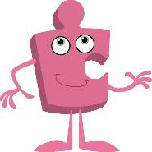 | Being me in My World  - Hopes and fears for the year  - Rights and responsibilities  - Rewards and consequences  - Safe and fair learning environment  - Valuing contributions  - Choices  Recognising feelings  Celebrating Difference  - Assumptions and stereotypes about gender  - Understanding bullying  - Standing up for self and others  - Making new friends  - Gender diversity  - Celebrating difference and remaining friends | RE   | What did Jesus teach?  Is it possible to be kind to everyone all the time?  Christmas -Jesus as a gift from God  Why do Christians believe God gave Jesus to the World?
ART   | Paul Klee ‘Castle and Sun’- oil pastels  Using 2D shapes, different media and colour to create pictures inspired by this art work  Watercolour painting  Artist: Martin Impey (illustrator)  Using a wash to create landscape pictures | Design and Technology  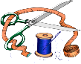

MUSIC   | Friendship Song  - Exploring music about friendship  - Singing and playing a simple accompaniment on glockenspiel  - Christmas performance  - Listening and appraising various styles of Christmas music  - Learning a Christmas song and rap | MFL | - Vegetables  - Learning 10 vegetables  - Adding a weight to vegetable phrases  - Role-play  - Extra weight and phrases for longer sentences
PE   | Gymnastic  Multi-skills  Dance Basketball | Additional information | Forest school for Year 2 is in the summer term PE days in term 1 are Tuesdays and Wednesdays.  PE days in term 2 are yet to be confirmed.

