Year 3-  Mr Barratt | Autumn Term 2022
 | Stone Age to Iron Age- As Solid as a Rock
English   | Recount  Asking the children to create a recount about one of their favourite days from the summer holidays.  Character Description:  We will be reading “The Twits” and using this to understand how to create a character description.  Creating their own character descriptions about a fictional character.  Instructions:  Read “how to wash a woolly mammoth”.  Use the text to understand how to write a set of instructions.  Write a set of instructions on how to dress a sabre tooth tiger”  Diary Entries:  Investigate Mary Anning.  Create a fact file of her life.  Create a diary entry for Mary Anning on the day she found the fossils.  Adventure Narrative  After looking at “The Stone Age boy” as an example of an adventure narrative, giving the children the opportunity to create their own stone age themed narrative.  Information Leaflets  After spending the term learning about the Stone, Bronze and Iron age. The children will be creating their own information leaflets on different aspects of the eras. | Maths  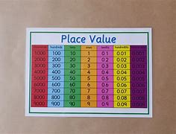 | Place Value:  Know the meaning of a number depending what column it is in within a number.  Basic addition and subtraction of these numbers.  Comparing numbers and ordering them.  Addition and Subtraction:  Add and subtract 1, 2 and 3-digit numbers whilst crossing a 10 or 100.  Use the written method in adding and subtracting.  Using the number line method  Length and Perimeter:  Find the length of a line using a ruler or adding lengths together.  Finding the perimeter or shapes on paper or physical objects in real life.  Multiplication and division:  To learn how to multiply and divide basic numbers up to 2-digit numbers.  Using the written method for multiplication  Know the grouping/sharing method for division.
SCIENCE  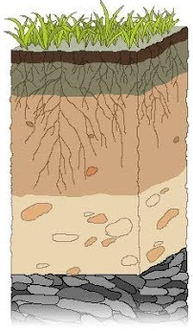 | Rocks:  - compare and group together different kinds of rocks on the basis of their appearance and simple physical properties  - describe in simple terms how fossils are formed when things that have lived are trapped within rock  - recognise that soils are made from rocks and organic matter.  - Understand the makeup of the earth and layer of soil.  - Know the 3 major rock types and how they are created  - investigate the suitability of rock types for jobs they do. | HISTORY  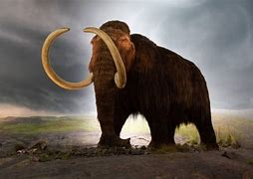 | Changes in Britain from the Stone Age to the Iron Age-  - e.g late Neolithic hunter-gatherers and early farmers, for example, Skara Brae  - Bronze Age religion, technology and travel, for example, Stonehenge, Iron Age hill forts: tribal kingdoms, farming, art and culture  - Food, housing, clothing and culture from the stone age through to the iron age  - How and why the Romans invaded England  - Understand how to use and understand reliable sources.
GEOGRAPHY  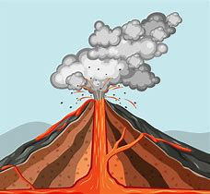 | Physical geography-  describe and understand key aspects of physical geography: volcanoes and earthquakes  What are tectonic plates and how are the laid out across the earth.  Locational Knowledge  - identify the position and significance of latitude, longitude, Equator, Northern Hemisphere, Southern Hemisphere, the Tropics of Cancer and Capricorn, Arctic and Antarctic Circle  - name and locate counties and cities of the United Kingdom, geographical regions and their identifying human and physical characteristics, key topographical features (including hills, mountains, coasts and rivers)  - To know some famous European volcanos and common earthquake sites.  Geographical skills and fieldwork  use the eight points of a compass  read and use a map. | COMPUTING  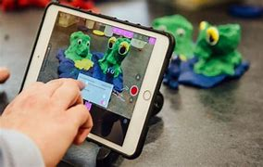 | Connecting Computers  Identifying that digital devices have inputs, processes and outputs, and how devices can to connected to make networks  Stop-frame animation  Capturing and editing digital still images to produce a stop-frame animation that tell a story
PSHE  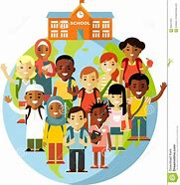 | Being me in My World  - Setting personal goals  - Self-identity and worth  - Positivity in challenges  - Rules, rights and responsibilities  - Rewards and consequences  - Responsible choices  - Seeing things from others’ perspectives  Celebrating Difference  - Families and their differences  - Family conflict and how to manage it (child-cantered)  - Witnessing bullying and how to solve it  - Recognising how words can be hurtful  Giving and receiving compliments | RE  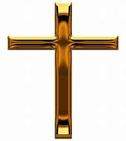 | Hinduism- Diwali  The children will be researching into the Hindu festival of light, Diwali.  They will investigate the story of Diwali, the celebrations of the festival, how Diwali makes Hindu children feel and how Diwali brings a sense of belonging to Hindus.  Christianity- Christmas  The children will be able to explain what Christmas means to them and if it receives giving or receiving gifts.  They will investigate the meaning of Christmas and the story behind it.  What does Christmas mean to Christians?
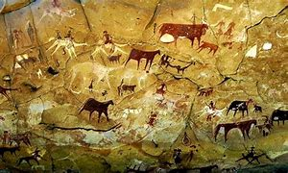  ART | Painting and Drawing  Using colour wash, charcoal, natural colours- techniques inspired by our ancestor’s cave paintings  To look at artists such as Banksy who create public art works and see how the cave paintings could be seen as an inspiration for them. | Design and Technology  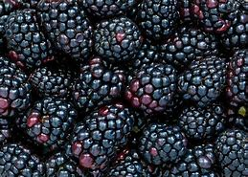 | Cookery-  Create a fruit stew recipe (tie in with Forest School)  Cook a fruit stew.  Test the fruit stew and evaluate how you would change it next time.
MUSIC  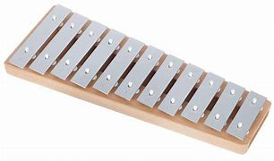 | Let your Spirit Fly  Listening and apprasing the song “Let your spirit fly” by Joanna Mangona  Glockenspiel Stage 1  Learning a simple accompaniment on the glockenspiel to go alongside the song. | MFL  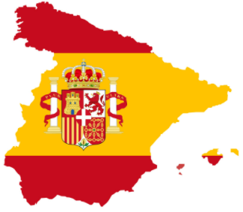 | Phonetics 1  I am Learning Spanish  Learn basics of the country of Spain. Their food, entertainment and culture.  Know the names of the colours.  Animals  To learn the names of common animals.
PE  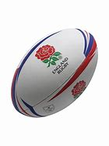 | Outdoor Learning  Games Tag-rugby  Games- Football  Dance  Basketball/Netball | Any additional bits | e.g. Forest school Autumn 1  PE days- Wednesday and Thursday  Homework days- Homework to be given out on a Friday and expected in on Wednesday  Spellings- Handed out on a Friday and tested on the following Friday.

