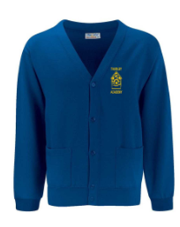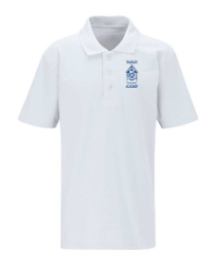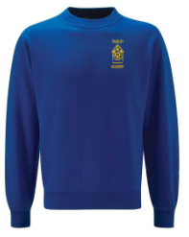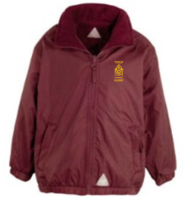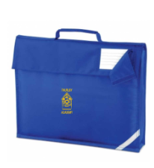

|  |  |  |
| --- | --- | --- |
| Item | Size | 2025 Prices |
| White Polo Shirt | All Sizes | £8.50 |
| Royal Blue Sweatshirt | All Sizes | £12.45 |
| Royal Blue Cardigan | All Sizes | £13.25 |
| Maroon Mistral Jacket | All Sizes | £21.99 |
| Navy PE Shorts | All Sizes | £4.99 |
| Royal Blue PE Polo Shirt | All Sizes | £8.50 |
| PE Sweatshirt Maroon | All Sizes | £11.75 |
| Royal Blue Cap | All Sizes | £6.75 |
| Royal Blue Book Bag | All Sizes | £6.99 |
| Royal Blue PE Bag | All Sizes | £6.50 |

