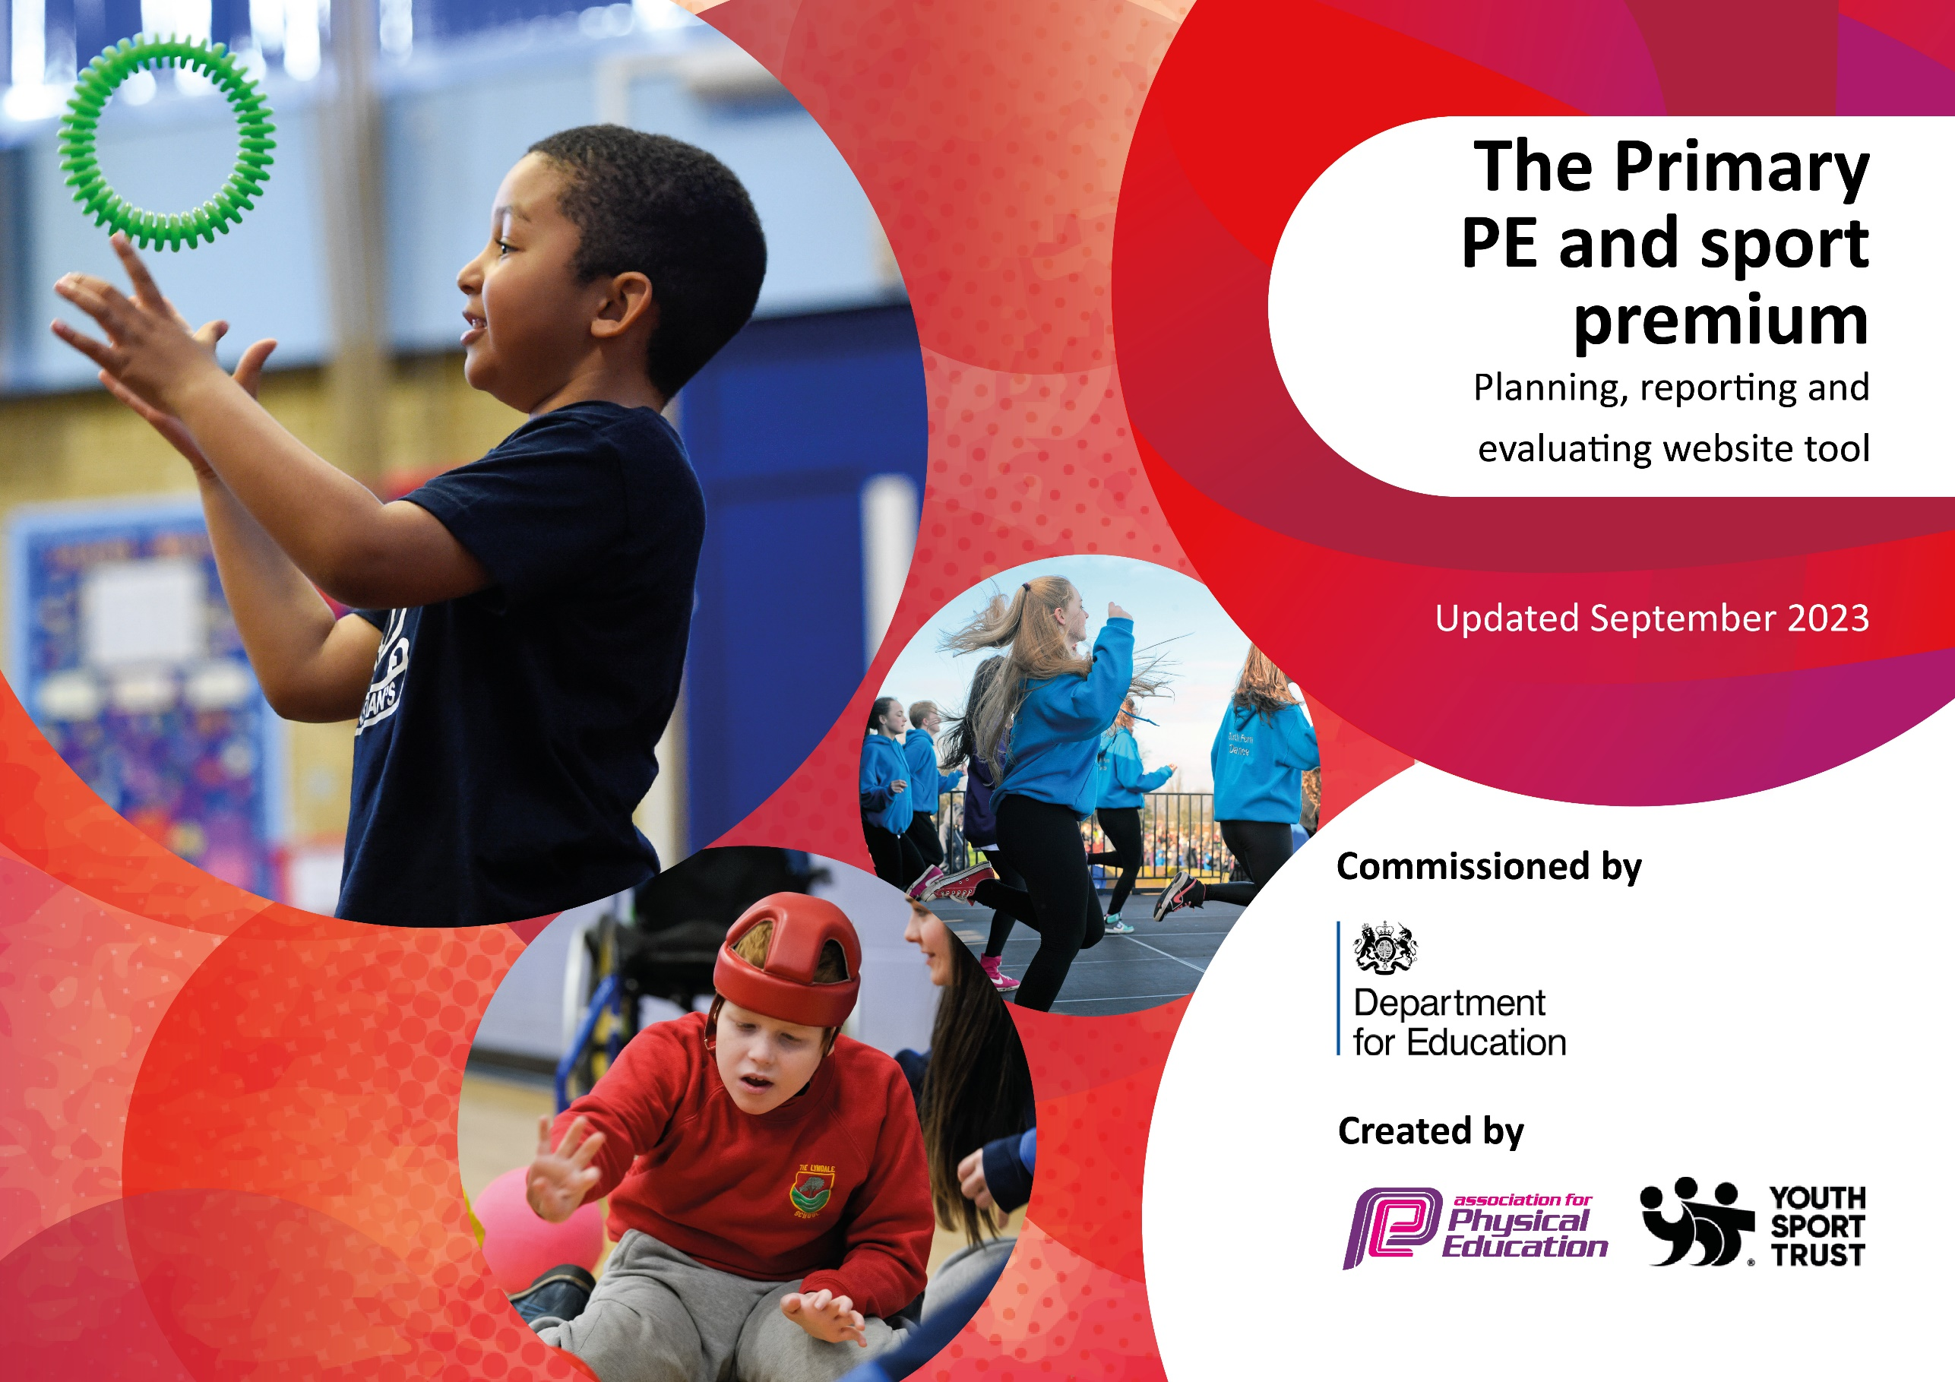

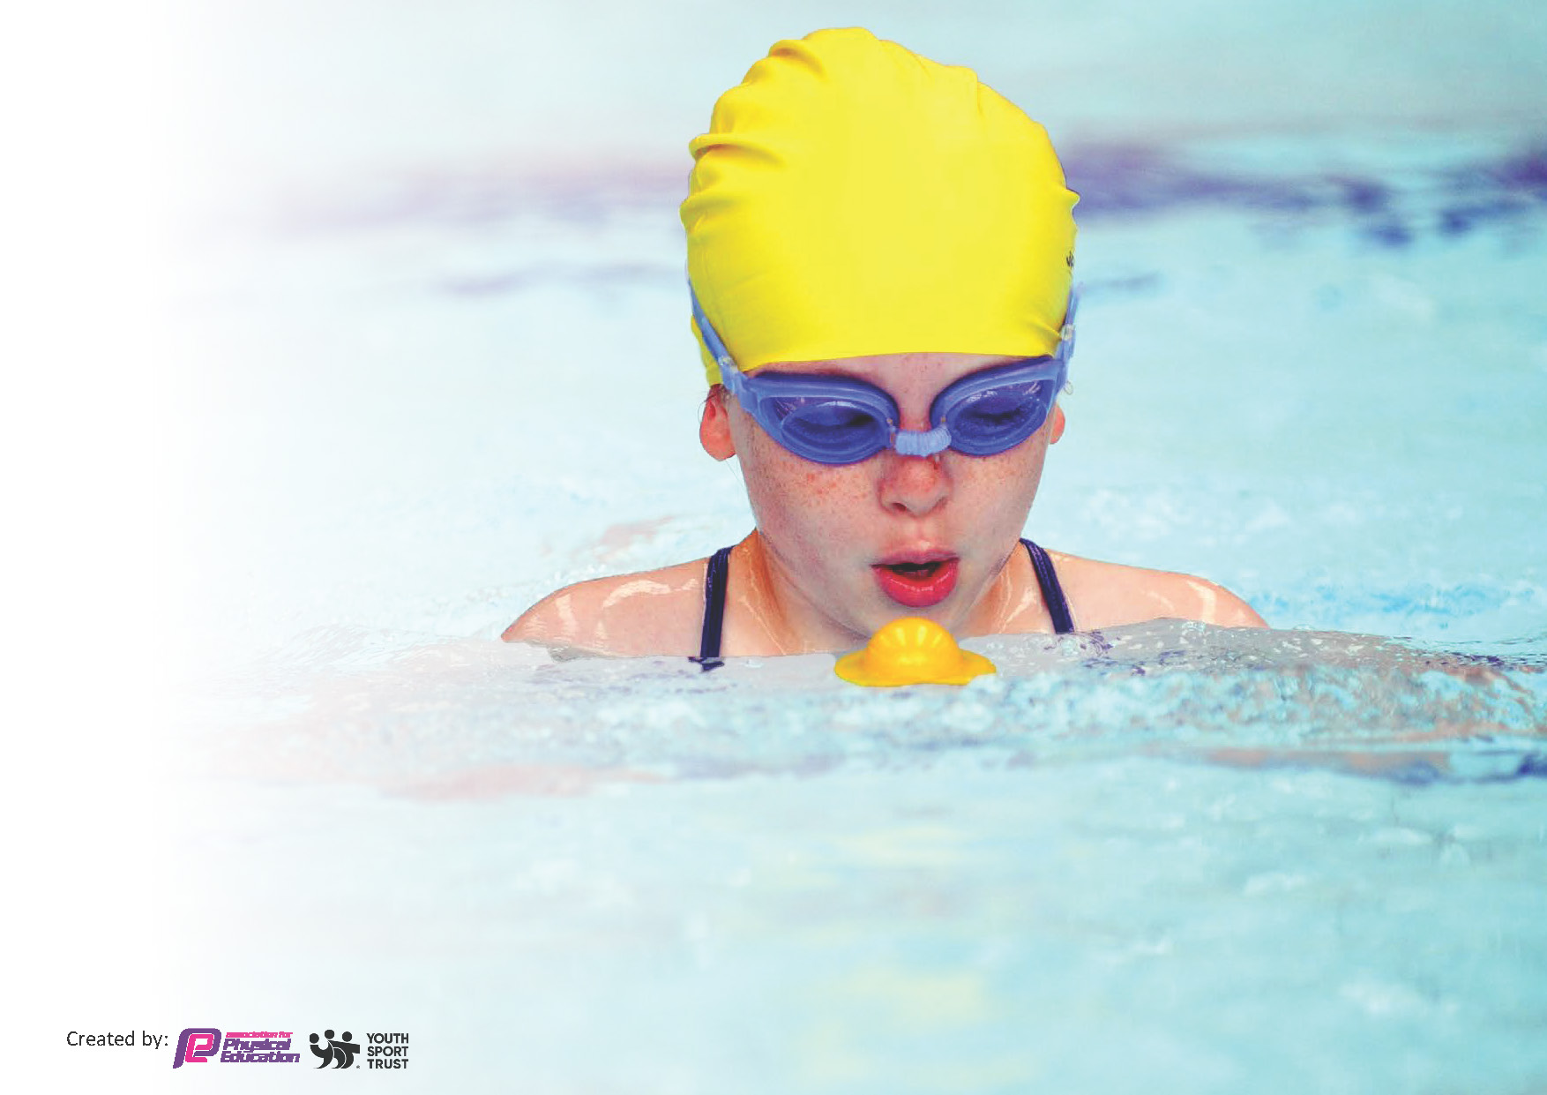
This template can be used for multiple purposes:
by:
- It enables schools to effectively plan their use of the Primary PE and sport premium
- It helps schools to meet the requirements (as set out in guidance) to publish information on their Primary PE and sport premium
- It will be an effective document to support Ofsted inspections enabling schools to evidence progress in Physical Education (PE) and evidence swimming attainment, which forms part of the PE National Curriculum. We would recommend schools consider
the Intent, Implementation and Impact of any spend, as examined within the Education Inspection Framework.

It is important that your grant is used effectively and based on school need.

Schools must use the funding to make additional and sustainable
improvements to the quality of the PE, School Sport and Physical Activity (PESSPA)
they offer. This means that you should use the Primary PE and sport premium to:

- Build capacity and capability within the school to ensure that improvements made now will benefit pupils joining the school in future years
- Develop or add to the PESSPA activities that your school already offers.

The Primary PE and sport premium should not be used to fund capital spend projects; the school’s core budget should fund these. Further detail on capital expenditure can be found in the updated Primary PE and sport premium guidance.

The Primary PE and sport premium guidance, outlines 5 key priorities that funding should be used towards. It is not

necessary that spending has to meet all the key priorities, you should select the priorities that you aim to use any funding towards.

Although completing this template is not a requirement for schools, schools are required to publish details of how they spend this funding. Schools must also outline what the impact this funding has had on pupils’ PE and sport participation and attainment and how any spending will be sustainable in the future. All funding must be spent by 31st July 2024.

The Department for Education has worked closely with the Association for Physical Education (afPE) and the Youth Sport Trust (YST) to develop this template and encourages schools to use it. This template is an effective way of meeting the reporting requirements of the Primary PE and sport premium.

Key priorities and Planning
This planning template will allow schools to accurately plan their spending.

Action – what are you planning to do | Who does this action impact? | Key indicator to meet | Impacts and how sustainability will be achieved? | Cost linked to the action
Play Leaders will be trained to lead activities for children at lunch times. | Lunchtime supervisors  Pupils as they will lead some of the activities and also participate | Key Indicator 2 - Engagement of all pupils in regular physical activity.  Key Indicator 3 - The profile of PE and sport is raised across the school as a tool for whole school improvement  Key Indicator 4 - Broader experience of a range of sports and physical activities offered to all pupils | More pupils meeting their daily physical goal.  More pupils encouraged to take part in PE and Sport Activities. | £150 cost for training  £500 for Play Leader resources
Purchase Complete PE scheme | All staff due to CPD opportunities  Pupils as they will benefit from staff’s CPD | Key Indicator 1 - Increased confidence, knowledge and skills of all staff in teaching PE and sport  Key Indicator 3 - The profile of PE and sport is raised across the school as a tool for whole school improvement  Key Indicator 4 - Broader experience of a range of sports and physical activities offered to all pupils | Curriculum mapping by PE Lead ensures range of coverage of skills and activities across age ranges and key stages.  Planning documents provide support for teachers whilst also ensuring consistency in approach.  Planning documents and subsequent support materials ensure children are exposed to a clear progression of skills.  Assessment tool allows staff to be explicitly aware of children’s strengths and areas for development.  Resources include plans for adapted practice. | £1200

Joining the offer from Agilitas Sports Partnership (South Kesteven) | Pupils as they will participate in events | Key Indicator 4 - Broader experience of a range of sports and physical activities offered to all pupils  Key Indicator 5 - Increased participation in competitive sport | Pupils are encouraged to join lunch time clubs in order to prepare for events therefore increasing their physical activity.  Staff’s confidence and skills are enhanced which directly impacts positively onto the teaching and learning in PE. Two ECTs and 3 teaching staff returning to the classroom after a teaching break so CPD is needed.  More pupils encouraged to take part in PE and Sport activities. | £250 contribution to the Agilitas Partnership  £1000 for further CPD opportunities throughout the year offered by Agilitas.  £2000 for transport costs to sporting events across South Kesteven (transport costs have risen significantly in the past year)
Purchase of services from Premier Sports to deliver lunchtime clubs and curriculum sessions | All staff due to CPD opportunities when they attend Premier run curriculum sessions.  All pupils due to increased extra curricular provision and benefit of teachers receiving CPD. | Key Indicator 1 - Increased confidence, knowledge and skills of all staff in teaching PE and sport  Key Indicator 2 - Engagement of all pupils in regular physical activity.  Key Indicator 3 - The profile of PE and sport is raised across the school as a tool for whole school improvement  Key Indicator 4 - Broader experience of a range of sports and physical activities offered to all pupils  Key Indicator 5 - Increased participation in competitive sport | More pupils meeting their daily physical goal.  More pupils encouraged to take part in PE and Sport Activities.  Pupils are encouraged to join lunch time clubs in order to prepare for events therefore increasing their physical activity.  Staff’s confidence and skills are enhanced which directly impacts positively onto the teaching and learning in PE. Two ECTs and 3 teaching staff returning to the classroom after a teaching break so CPD is needed.  More pupils encouraged to take part in PE and Sport activities. | £2500 lunch time clubs for the academic year  £7000 for curriculum sessions led by Premier Sports
Purchase of services from ‘Roots to Food’ | Pupils as they will all directly be involved in the preparation and cooking of food whilst learning about nutrition and health. | Key Indicator 2 - Engagement of all pupils in regular physical activity.  Key Indicator 4 - Broader experience of a range of sports and physical activities offered to all pupils | Pupils will be more aware of the need for good nutrition due to its health benefits.  Children will be involved in menu planning, meal preparation and cooking of food.  Y6 will also present a Gala dinner to their parents.  Autumn – EYFS/Y1/Y6 – Italian food  Spring - Y2/Y3- Chinese food  Y4/Y5 Greek food  Summer – Y6 Gala dinner | £2500

Key achievements 2023-2024
This template will be completed at the end of the academic year and will showcase the key achievements schools have made with their Primary PE and sport premium spending.

Activity/Action | Impact | Comments
- Play Leaders trained with rota for daily provision for Reception and KS1 children.  - Complete PE schemed purchased and used for the full academic year.  - Agilitas Sports Partnership joined  - Premier Sports Education purchased for curriculum time and after school provision. | - Lunchtime supervisors are upskilled through training  - Play Leaders upskilled and able to demonstrate many Thurlby values  - Reception and KS1 children have better opportunities at lunch times which helps them to develop skills.  - Upskilled teachers  - Better progression for the children within their year groups and across the school.  - Children able to access competitions and festivals outside of school and the Trust.  - Access to further training from Agilitas  - Staff upskilled through observation and participation.  - Children have expert coaching and therefore have good progression of skills and knowledge. | It was a very successful year for the Play Leaders. The younger children appreciated their support and good relationships were developed.  Thurlby will continue with this initiative.  Review indicated that staff, overall, were happy with the new scheme. Reception would like to make tweaks to their units – action for the new year.  Some changes of staff throughout the academic year. Discussion with Premier Education Lead about consistency as

Swimming Data
Meeting National Curriculum requirements for swimming and water safety.
Priority should always be given to ensuring that pupils can perform safe self-rescue even if they do not fully meet the first two requirements of the National Curriculum programme of study

Question | Stats: | Further context  Relative to local challenges
What percentage of your current Year 6 cohort can swim competently, confidently and proficiently over a distance of at least 25 metres? | 84% | 27/31 children achieved 25m in their school swimming lessons in Spring 2023.  1 child is new to the school, therefore 5 children will be offered swimming sessions in Spring 2024.  £200 budgeted for this.

Signed off by:

Head Teacher: | Katherine Finch
Subject Leader or the individual responsible for the Primary PE and sport premium: | Jayne Sewell  Deputy Headteacher  PE Lead
Governor: | Dr. J. Jagger  Chair of Governors
Date: | October 2023

